The best paid celebrities of 2017

We all associate fame with fortune, travel, expensive brands and luxurious cars. Undoubtedly being a celebrity has many benefits, mainly when it comes to money. Although, some of them have an enviable bank account, others are just unimaginable. These, are the best paid celebrities of the year. Take a look at their fortunes, they will surely surprise you. Ready to know who’s in the first place? You won’t imagine it at all.

P. Diddy
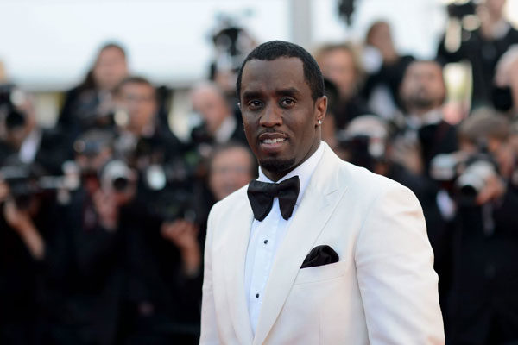

Leading the list is the number one American rapper with a total fortune of 820 million dollars. His income this year alone was 130. Can you imagine what would you do with all that money?

Beyoncé
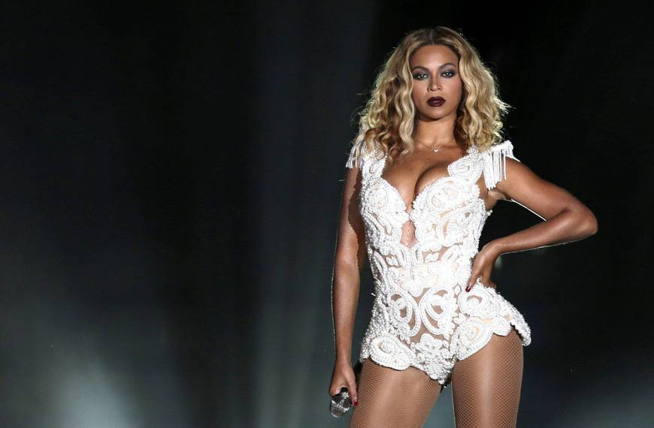
It is not difficult to imagine that she is in the second place on this list, this year she managed to add 105 million dollars to her account. Easy, right? ...

J.K. Rowling
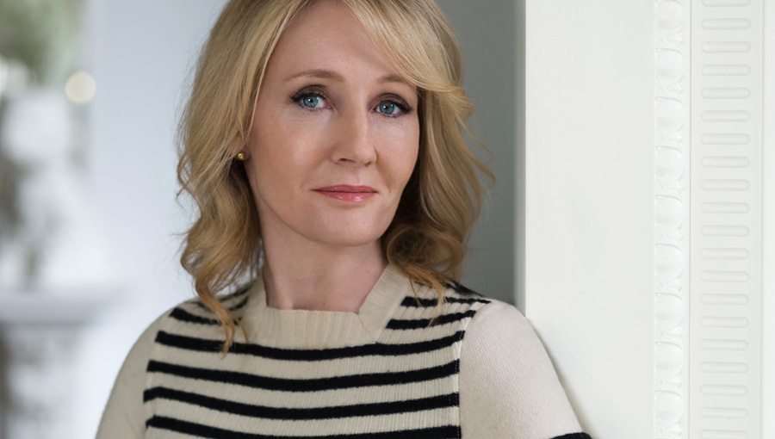

We all know this writer was born in the United Kingdom for her incredible fantasy book, Harry Potter. This year he added 95 million dollars to his bank account.

Drake
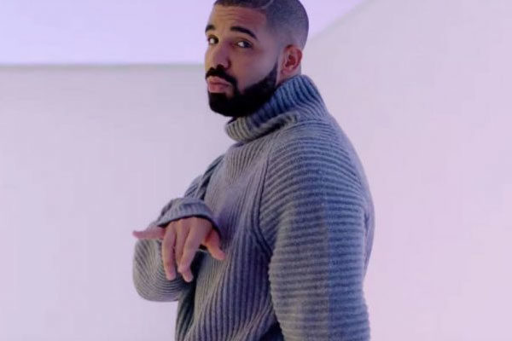

The Canadian rapper is one of the best paid singers in the world. He accumulated the incredible amount of 94 million dollars with his incredible song that have made us all dance. Yes people it is “Hotline Bling”.

Cristiano Ronaldo

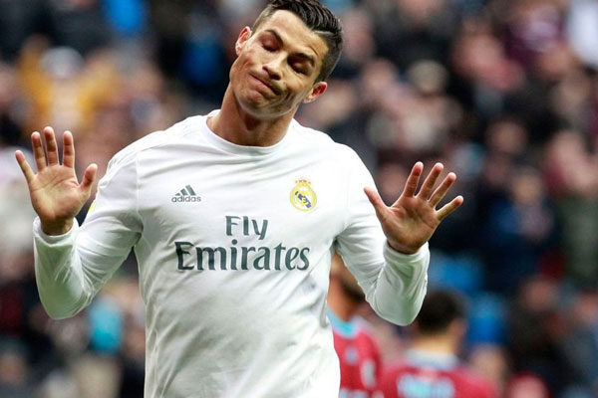
He is believed to be one of the most well-known and attractive footballers, and not only that, he is also one of the best paid with an amount of 93 million dollars.

The Weeknd

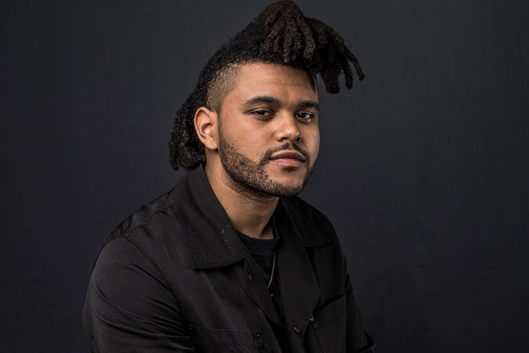

Abel Makkonen, better known as The Weeknd, is the Canadian singer who has surprised and caught us all with his unique music. In the last year he increased his fortune with 92 million dollars.

Howard Stern
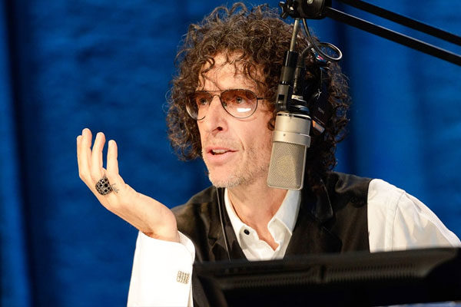

This American radio and television celebrity managed to achieve great fame and is now among the best paid name in the industry. He won 90 million dollars just this year.

Coldplay
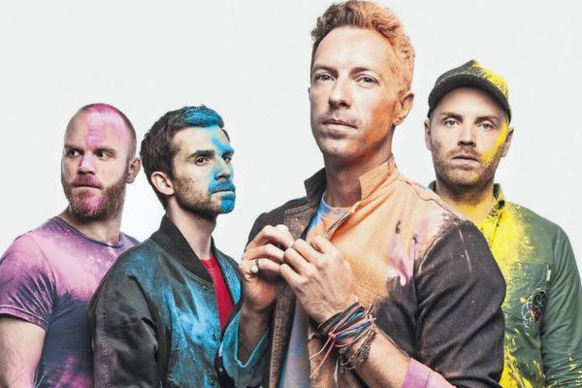

The most talented British rock music band is undoubtedly one of the best paid for their incredible music and concerts. This year they managed to add $ 88 million more to their bank account.

James Patterson

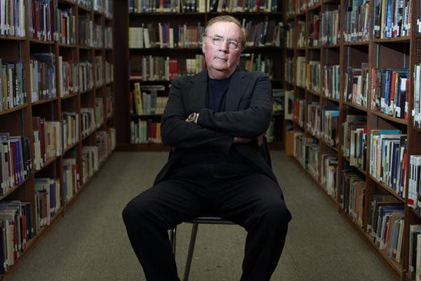

This author and American philanthropist is best known for his suspense books "Alex Cross". 87 million dollars were added to his bank account this year.

LeBron James
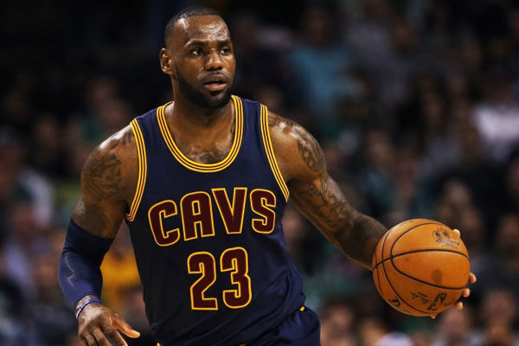

Any sport or basketball fan knows the reason for his fortune. He is one of the best players in the United States and managed to add $ 86 million more to his bank account this year.

Rush Limbaugh
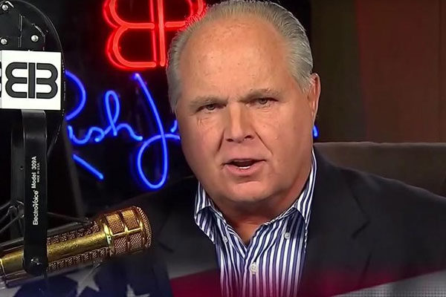

He is one of the best-known personalities on American radio for being a conservative commentator on politics. This year he won nothing more and nothing less than 84 million dollars.

Justin Bieber

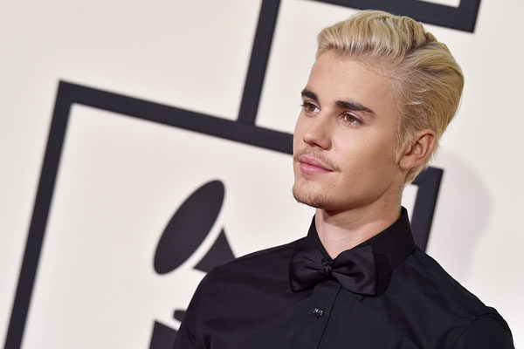

Although he is one of the youngest on the list, it does not stop him from being one of the best paid and recognized singers in the world. This year he earned 83.5 million dollars thanks to his incredible talent and fame, achieving position among the first places with his well-known songs.

Lionel Messi

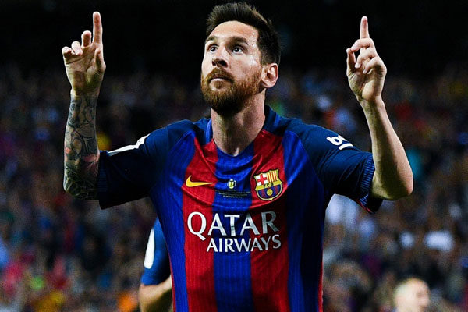

Even if you do not like football you know this athlete, and like Cristiano, he is one of the most well paid football players, with 80 million dollars that were added to his bank account this year.

Dr. Phil McGraw

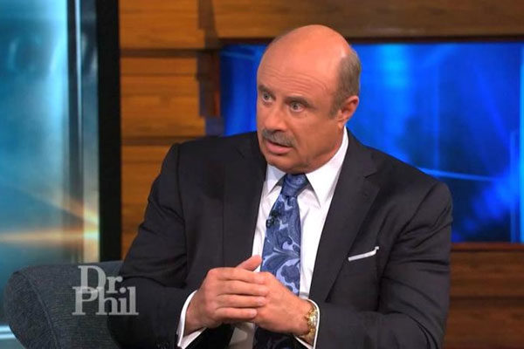

The television presenter not only has his own show called Dr. Phil but he is also one of the most well paid personalities, with an amount of 79 million dollars this year.

Ellen DeGeneres

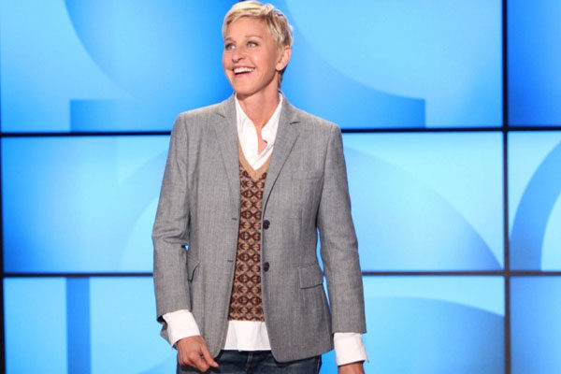

Ellen undoubtedly is a well-known comedian and American television presenter. She added to her fortune the amount of 77 million dollars this year.

Bruce Springsteen

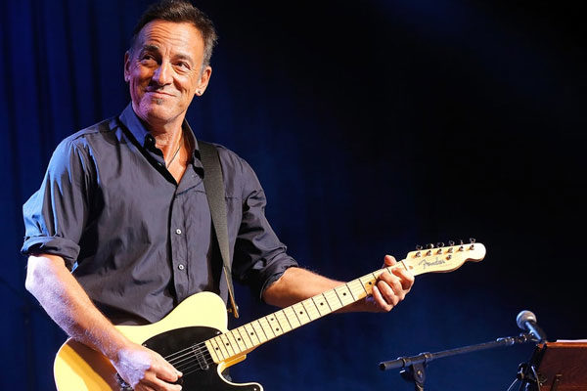

The singer and composer remains on the list thanks to his great talent and incredible songs. He won this year 75 million dollars. OMG.

Adele

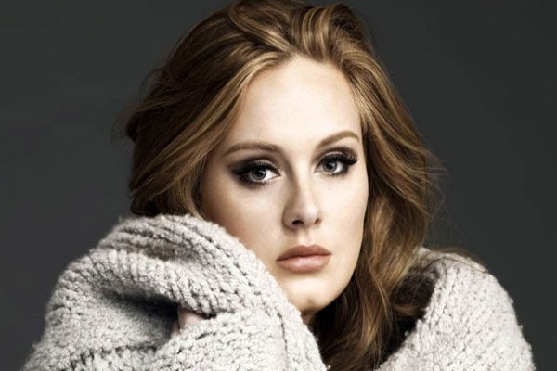
This English singer is also one of the youngest and most recent celebrities on this list. His wonderful voice managed to achieve fame in a short time and his fortune continues to rise, this year with 69 million dollars.

Jerry Seinfeld

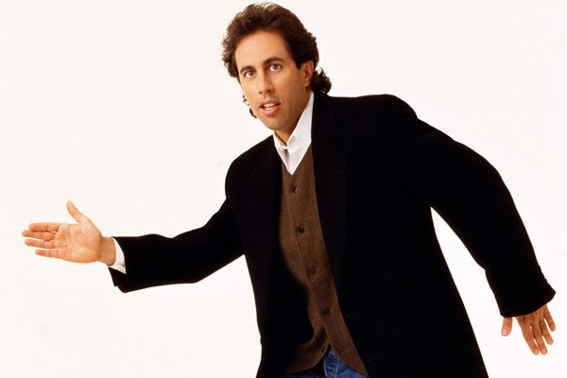

The comedian and actor who does not go out of fashion continues making his fortune grow. This year he won 69 million dollars. Amazing, right?

Mark Wahlberg

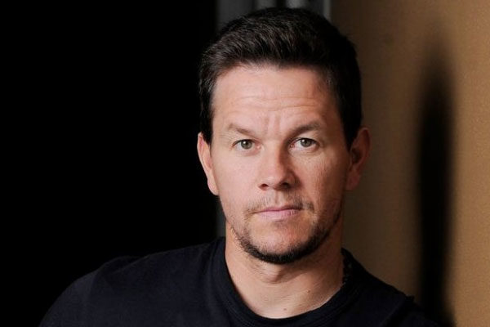

The talented American actor and producer is unstoppable not only in his roles in the action films, but also in his fortune, this year he won 68 million dollars.

Dwayne “The Rock” Johnson

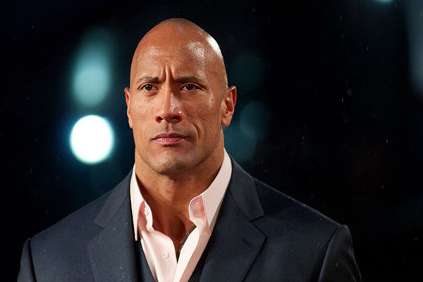

The actor and professional wrestler has managed to stand out both in the middle of the action and in world wrestling championships. The amount of money that he added to his bank account this year was 65 million dollars.

