The 20 historical moments immortalized in exceptional pictures

There are some things that I would not have imagined that had been captured in a picture. Sometimes I think the importance of capturing. Moments can be lived only ones, there is no discussion with that. However, knowing that we can actually capture that moment with a picture and then show it exactly how it happened to someone else is something that is quite impressive for me. Here, we are going to share 20 historical 20th century moments that were captured in pictures.

- Hitler
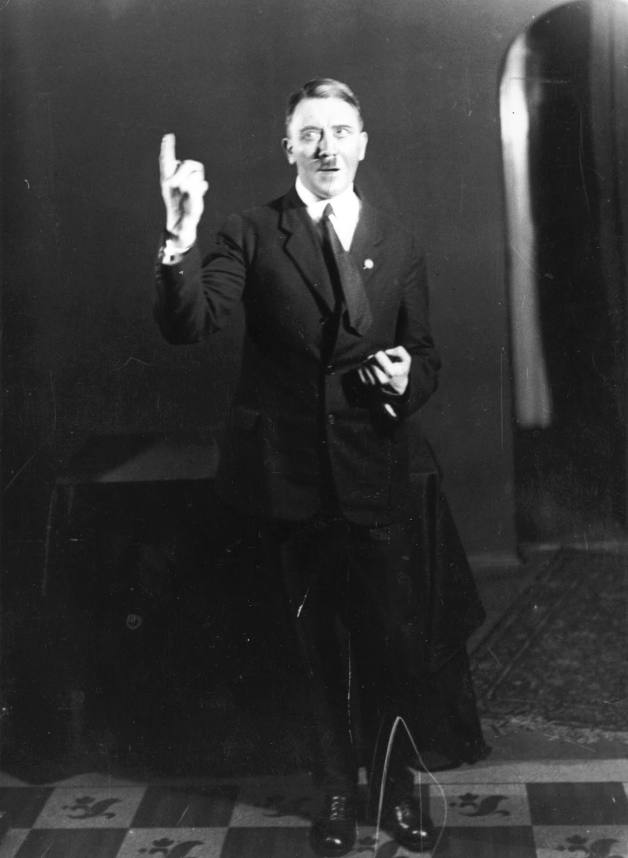

Hitler acting, he rehearses his speech in front of the mirror in 1925. Weird in a lot of ways, I personally didn’t know that this type of figure had to rehearse what he was going to say or not say…

- Love is in the air
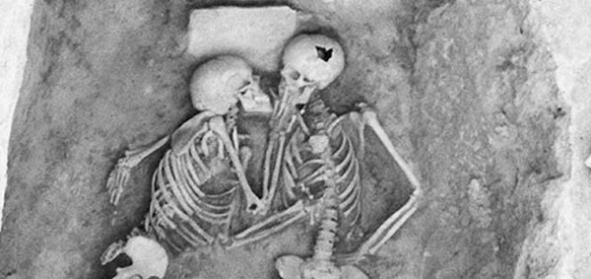

The kiss of 2800 years. Two bodies discovered in a grave in Iran, in 1972. Their tragic death occurred when the village was burned during a military attack. Even tough, they are just bones and they are already dead it looks like the most romantic way to die.

- Hand in hand walk
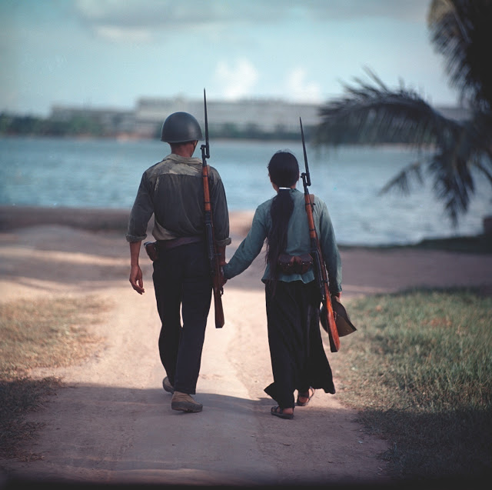

Vietnamese soldiers. Two fighters walk hand in hand in Vietnam, in 1971. This is one of the most romantic pictures I’ve ever seen in the world. You should think that they are not sure of how much time left they have.

- Japanese

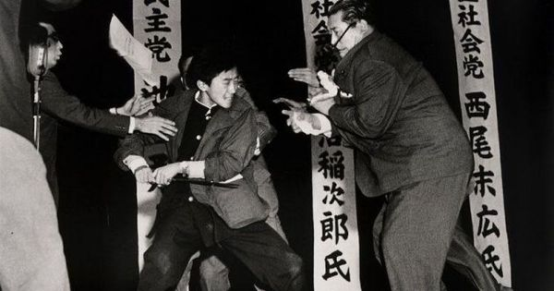

The murder. A 17-year-old boy murders the leader of the Socialist Party of that country, Inejiro Asanuma, on October 12, 1960, with a traditional Japanese saber.

- Paradoxical

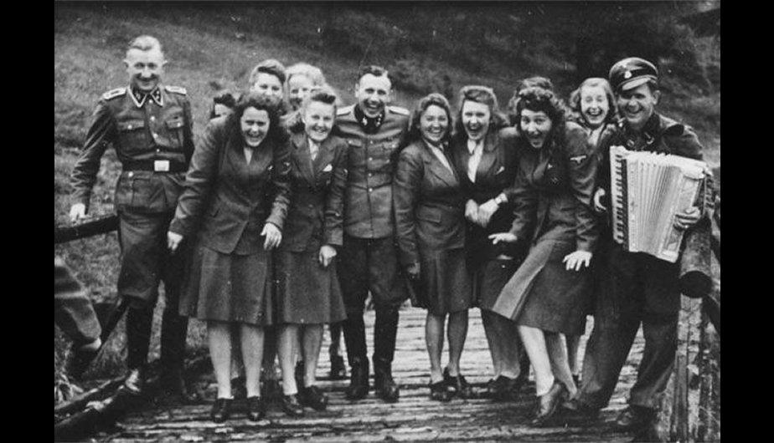

Auschwitz SS officers and secretaries pose for picture at the Auschwitz concentration camp, in 1942 which seems quite nonsense. Look at those happy faces. I get they are just officers but i feel like those faces are really forced.

- A gifted kid
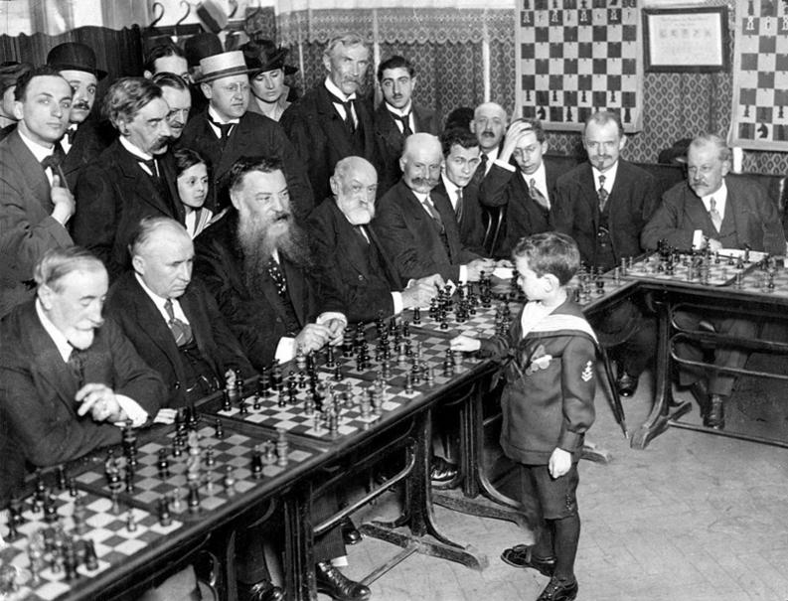

Samuel Reshevsky. The prodigy child Samuel Reshevsky easily defeats several chess masters simultaneously, being just 8 years of age in 1920. Pretty amazing, right? I couldn’t believe it till I saw it in the picture.

- Happy Stalin
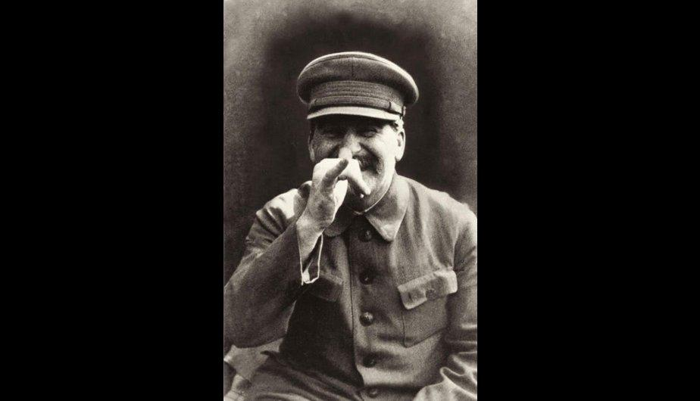

Joseph Stalin. The Soviet leader is captured in a relaxed and informal pose, in a picture taken by his personal bodyguard. I don’t think he could ever imagine that a picture like this could possibly exist.

- Scary baby masks

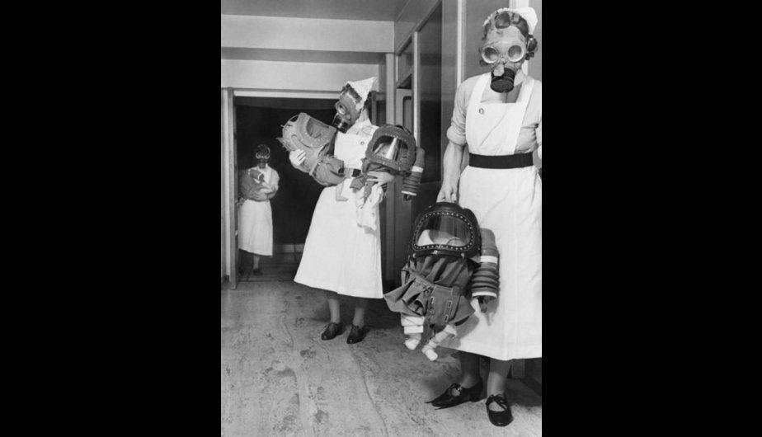

Small gas masks In a British hospital, nurses try gas masks for babies, in 1940. This picture looks quite creepy to me. I get that they are gas masks and that they are in a hospital., but it doesn’t matter their faces with those masks are too much for my eyes.

- Goebbels
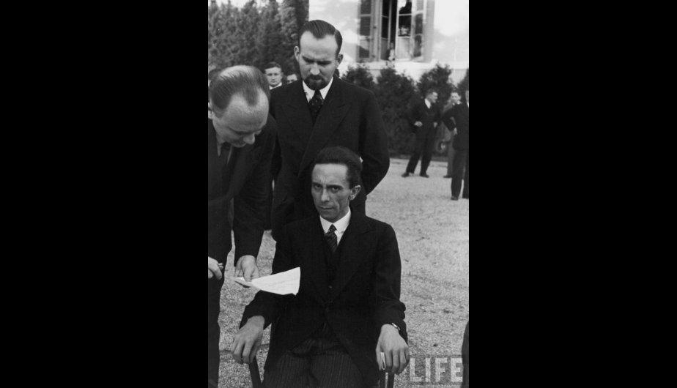

Joseph Goebbels. The propaganda minister of the Nazi regime is photographed seconds after learning that the Life magazine photographer is Jewish. OMG his face in terrific.

- Nine Kings at Buckingham Palace

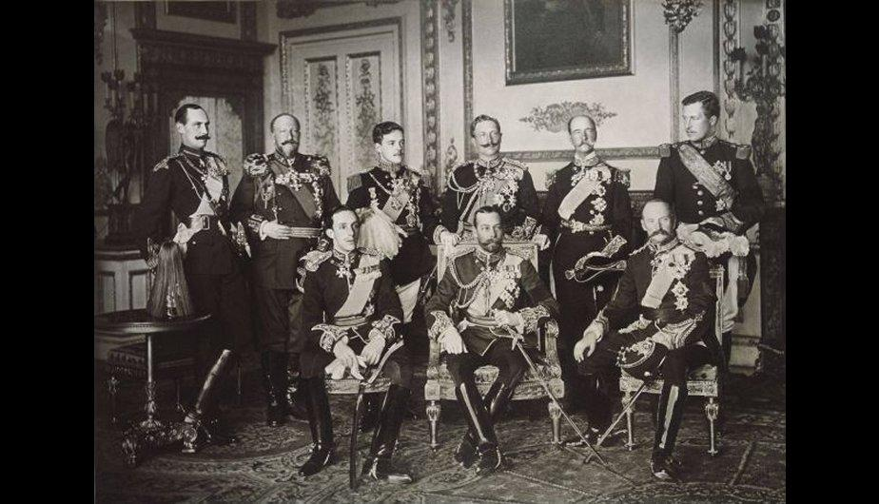

The 9 kings. In May 1910, all European royalty gathered for the funeral of King Edward VII of the United Kingdom. Look at their expressions, most of them are looking to a different place. That seemed a little bit weird to me. Did you noticed that too?

- Solvay congress

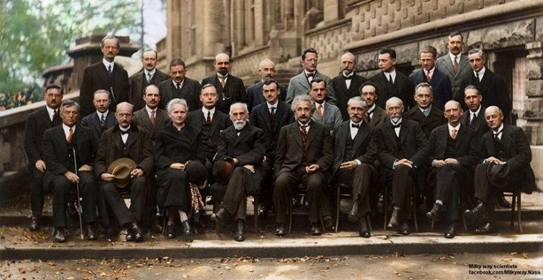

The Fifth Solvay Congress. In 1927, the world's leading scientists met and took the most famous and important picture in the science history.

- Last guillotine execution
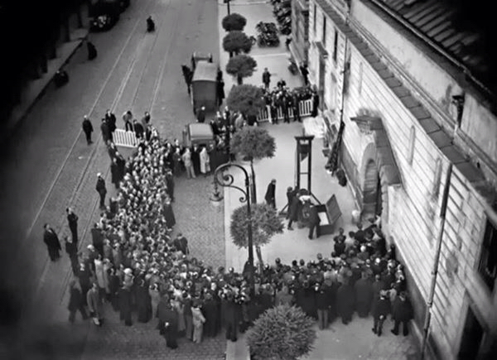
The end of the guillotine. Last public execution in the guillotine, carried out in France in 1939. This is a drastic sentence. I am truly in favor of this decision. I mean, it was not only cruel but also inhuman. I feel like there are millions ways of changing a criminal so that it can live in society again.

- Prohibition ending

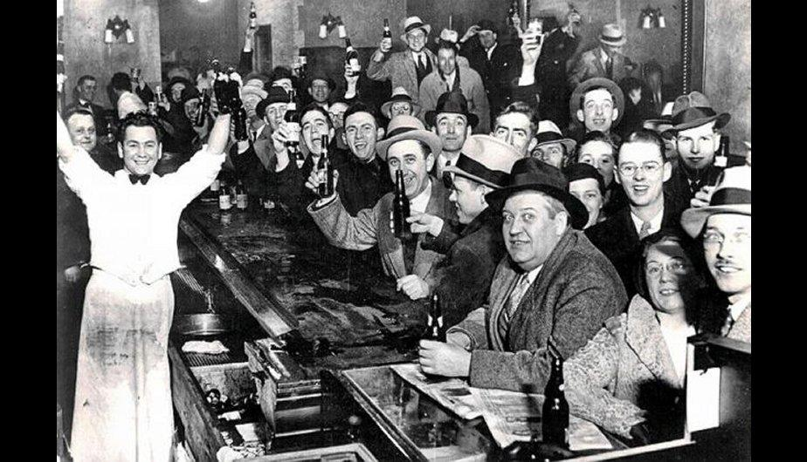

The end of the prohibition. Taken in a bar in the United States on December 5, 1933, the day the Prohibition was terminated. Everyone was so happy, look at their faces!

- Hitler again
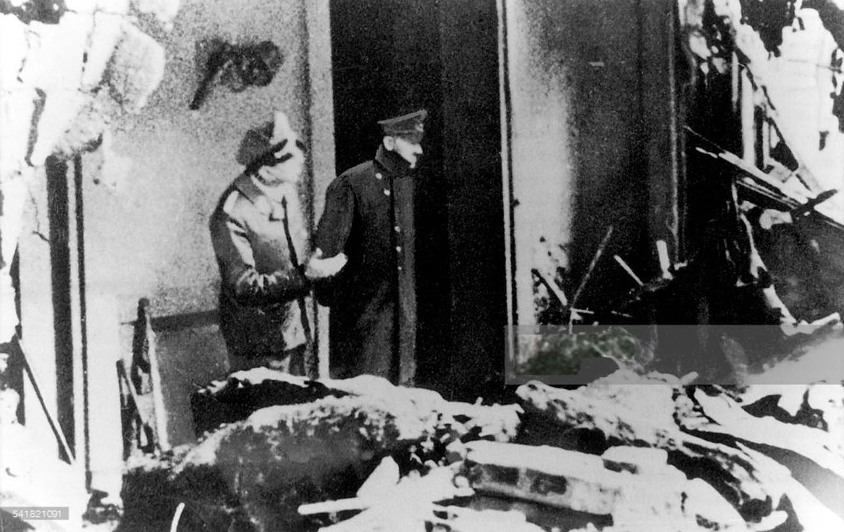

The last picture of Adolf Hitler. The last image of Adolf Hitler, taken on April 30, 1945, hours before he committed suicide. Well, kind of. Some people don’t believe that he committed suicide, they think he was hidden somewhere for a long time. Quite a mystery…

- Color picture
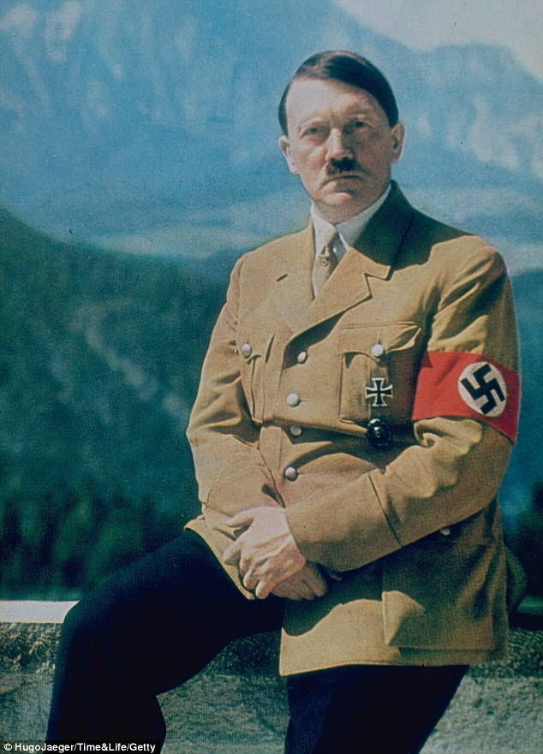

Adolf Hitler in color. One of the few color pictures of him. I believe there are more original pictures in color of him. However, some others are photoshoped and were in black and white originally.

- German soldiers

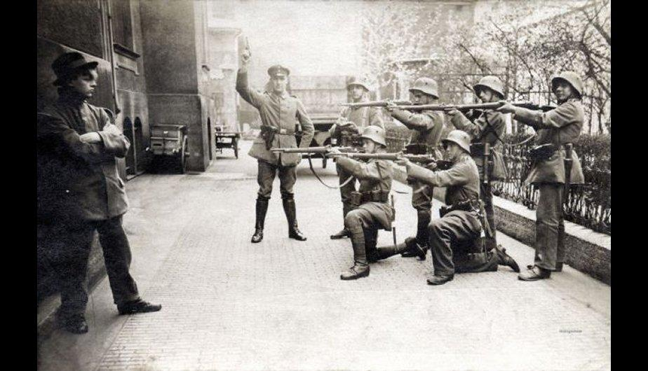

Execution. German soldiers prepare to execute a communist militant in Munich, 1919. Can you possibly imagine yourself preparing for an execution? This doesn’t even fits in my own head. It should be quite difficult not only physically but also mentally talking.

- Versailles treaty
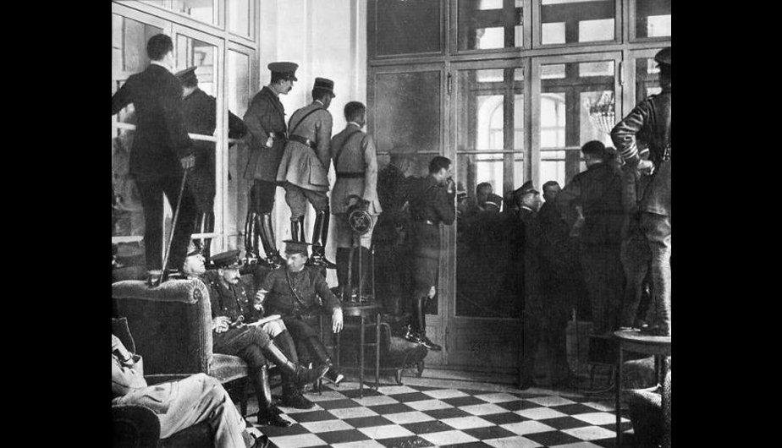

Treaty of Versailles. Witnesses stand on chairs and furniture to witness the signing of the Treaty of Versailles, in 1919. I would’ve done the same with no doubt. Imagine living that moment! Of course I would spy.

- Nazi soldier’s oath

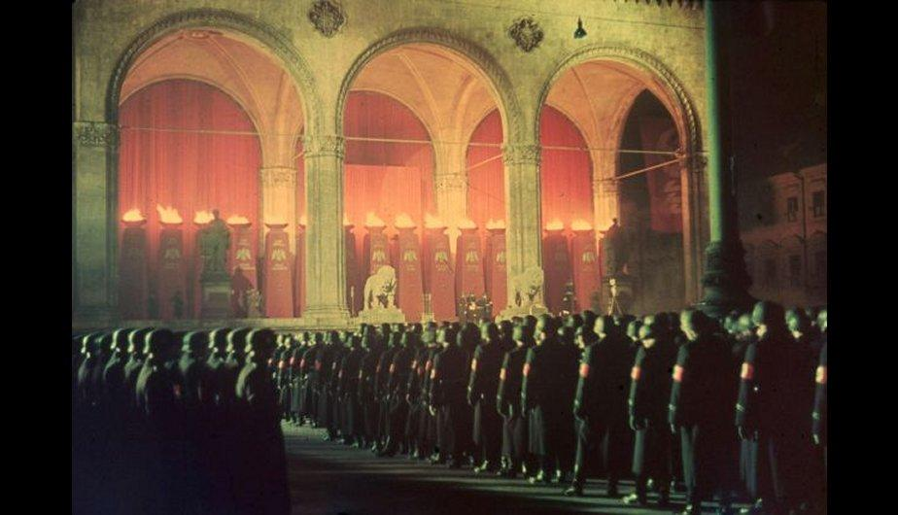

Oath of Nazi soldiers. In 1938, a year before the start of World War II, Nazi SS troops take oath in Feldherrnhalle, Munich. Who would’ve thought that the second world war was going to take place one year after? Crazy…

- Soviet soldiers
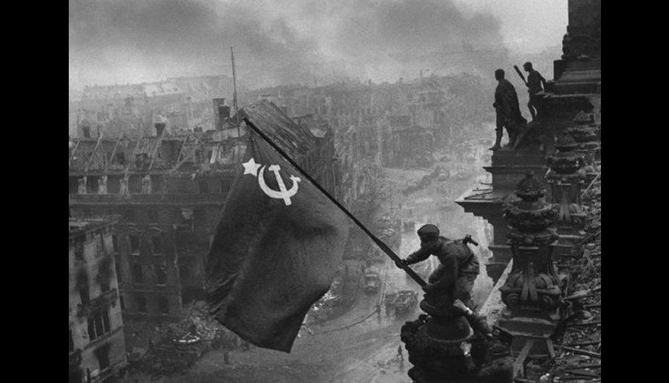

Soviet soldiers in Berlin. In 1945, after the Nazi defeat in World War II, Soviet soldiers raise the flag of the USSR in Berlin. WOW, this picture looks as if it was taken from a futuristic movie, right?

- Franz Ferdinand, the Archduke
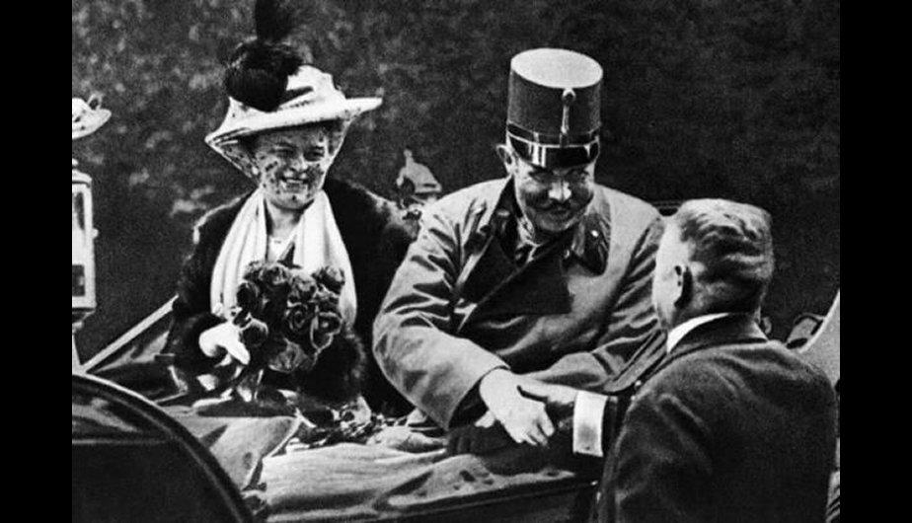

The Archduke Franz Ferdinand of Austria and his wife. June 28, 1914, the day they were killed in Sarajevo, a fact that triggered the First World War. I can’t believe a moment like this could be captured. It is impressive.

