Surprising twin’s stories who were separated at birth!

People say that twins have a certain connection that nobody can explain or even understand. The possibility that two people will meet again after having been separated at birth is very unlikely. Here, we are going to share some twin’s stories that were adopted by different families and managed to rediscover themselves.

These cases seem taken from a soap opera and will surely move you, they will leave you wondering whether they are true or not! These are some stories of separated twins at birth and managed to reunite years later.

Emilie Falk and Lin Backman

These sisters born in Indonesia were adopted by different families in Sweden and lived only 20 miles away for decades until they managed to find each other on Facebook and finally arranged a meeting.

Ann Hunt and Elizabeth Hamel

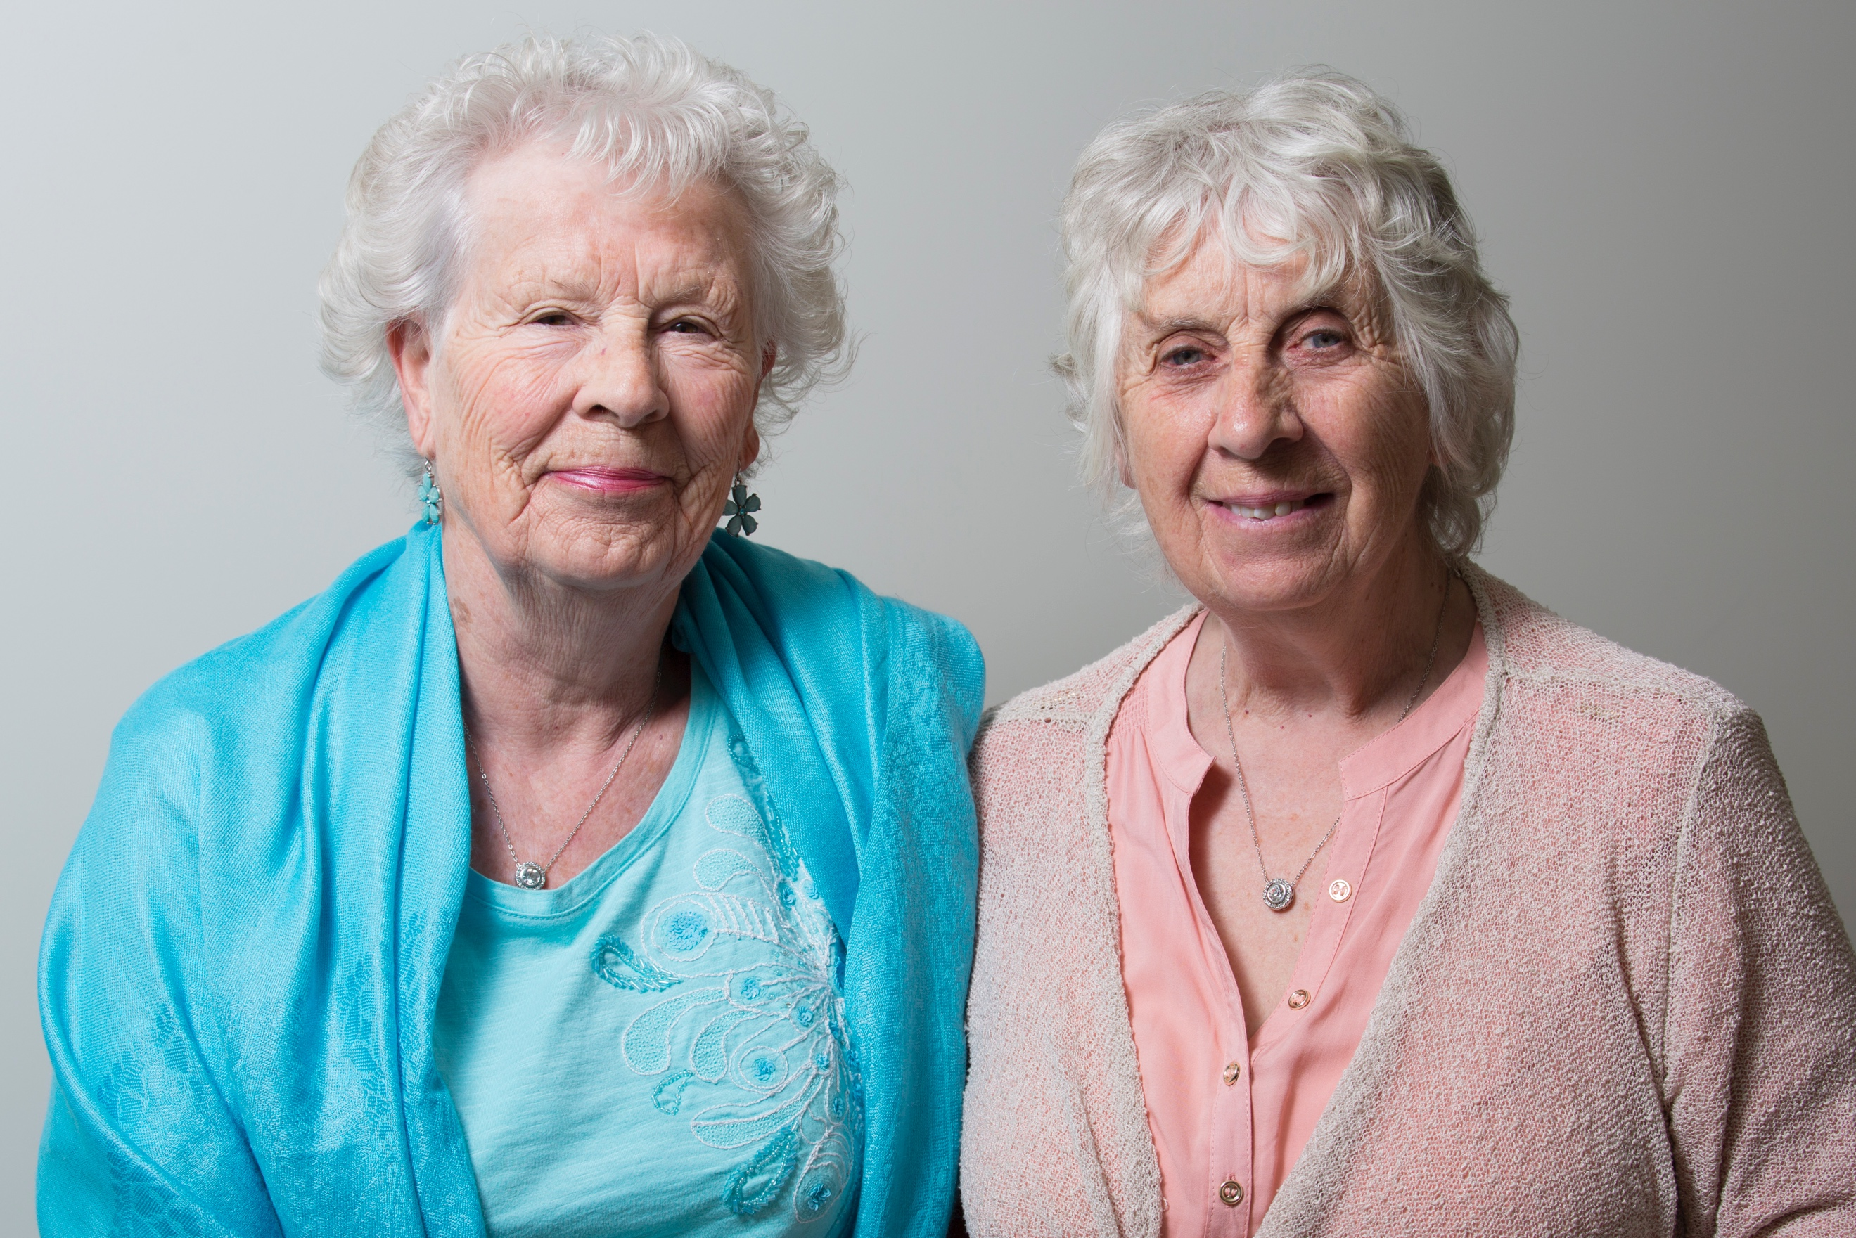

These twins were born in Los Angeles and were separated when they were only 5 months old, to be able to meet they had to spend 80 years. The moment they could meet again was very moving. They had spent many years looking for each other.

Jim Lewis and Jim Springer

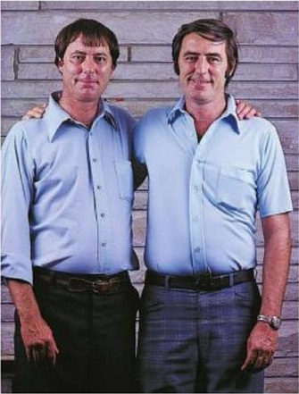
They were separated four weeks after they were born and, at the age of 5, were adopted by different families. Lewis found out that he had a twin brother and did not stop looking for him until he finally met Jim at the age of 38. The funny thing is that they both have the same name, weight and also the same height.

Barbara Herbert and Daphne Goodship

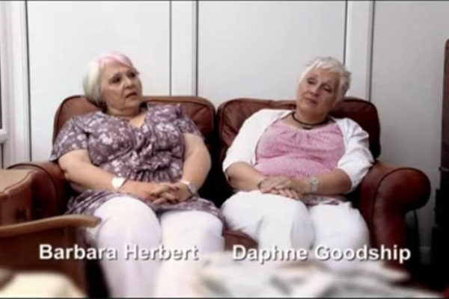

These twins are well known as they spent more than 40 years without knowing each other and still have many things in common, such as the way they laugh and how they bend their arms. Most surprising is that they both had miscarriages and subsequently each one gave birth to two children and a girl.

Marlon and Marlone
These Brazilian twin brothers were separated at birth because their mother gave birth when she was only 14 years old and decided to give them up for adoption since she could not take care of them.

Their passion for football untied them years later.

At age of 12 they met again in Rio de Janeiro when one of them was playing Brazilian football for a team.

Audrey Doering and Gracie Rainsberry

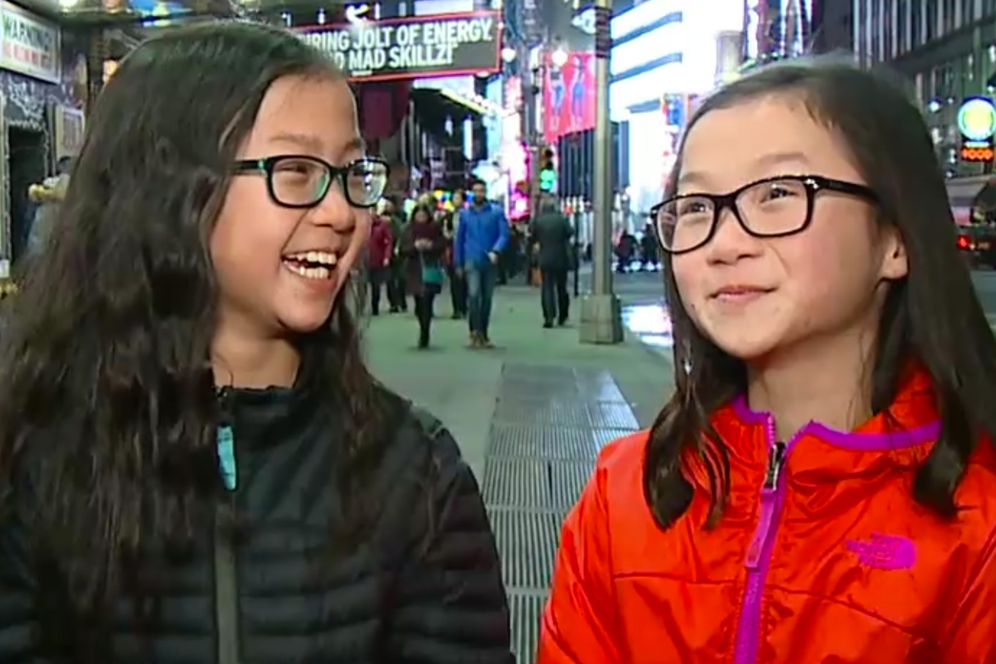

They were separated at birth in China and both were adopted by American families in 2017. Both suffered from the same condition of heart problems and had the same surgeries. The moment they met again was very moving and they hugged it out in the most tender way they could.

Anais Bordier and Samantha Futerman

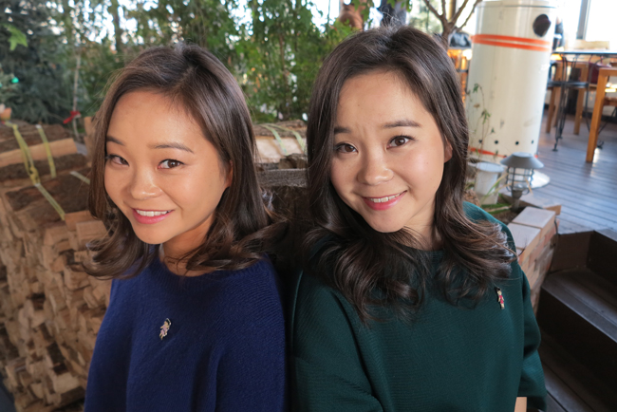
After 25 years, these twins could meet again in a very curious way. Anais, who studied fashion design in London, saw her sister starring in a video in Los Angeles and immediately contacted her, since then they have been inseparable.

Jorge, William, Carlos, y Wilber
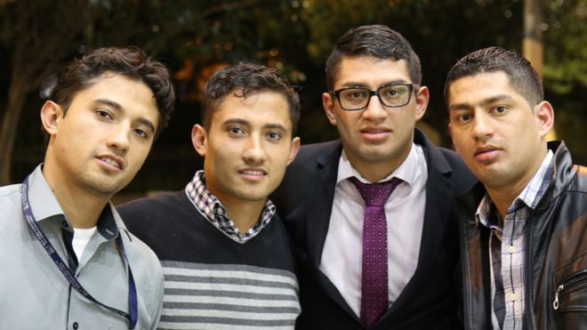
This incredible story happened in Colombia in 2015, pairs of identical twins were exchanged at birth by mistake and grew up believing that they were fraternal twins.

Their reunion was surprising for all

Thanks to the help of a friend of Jorge, who went to the supermarket and noticed the similarity with Carlos, they managed to rediscover themselves. The 4 brothers could not believe it.

Paula Bernstein and Elyse Schein
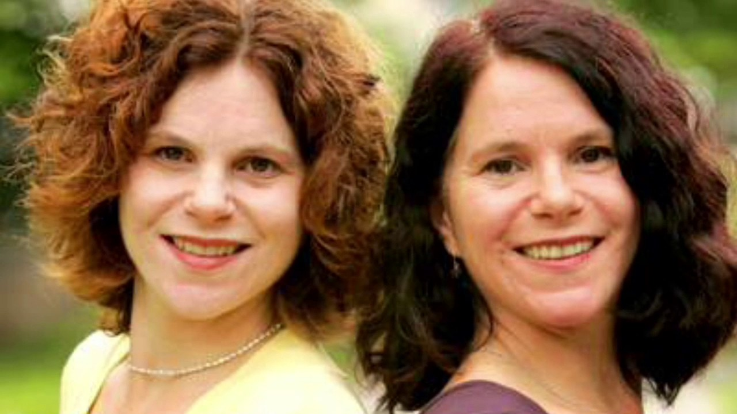

These twins born in New York were separated at birth for a study of twins. Both were raised by similar family environments and when they found themselves they decided to write a book about their experiences in order to get to know each other.

Tom Patterson y Steve Tazumi

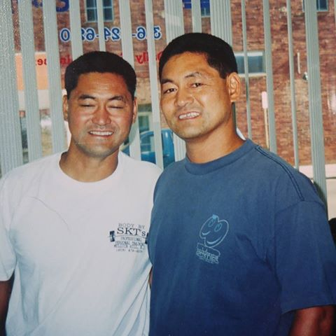

After their parent’s death, these brothers were separated. They continued having many similarities, including their jobs. They are now, owners of different gymnasiums.

Debbie Mehlman y Sharon Poset

Raised in very different ways, these sisters who were separated at birth were able to reunite at the age of 45. Both were dedicated to social work and shared the same hobbies, they also had a very peculiar way to show their excitement, they crossed their eyes.

Anna Kandl y Ella Cuares

These twins were abandoned by their mother in China and both were sent to different places to be raised. The parents who adopted them decided to keep in contact and did a DNA test to verify that they were sisters and when they obtained positive results they decided to reunite them.

Meredith Grace Rittenhouse y Meredith Ellen Harrington

These twins were separated and adopted by different families, growing one in Chicago and the other in Los Angeles. Their parents were part of a group of adoptive parents and saw a picture of one of them what made them get in touch to get to know the other one. Since then, they spend the holidays together.

Bobby Shafran, David Kellman y Eddy Galland
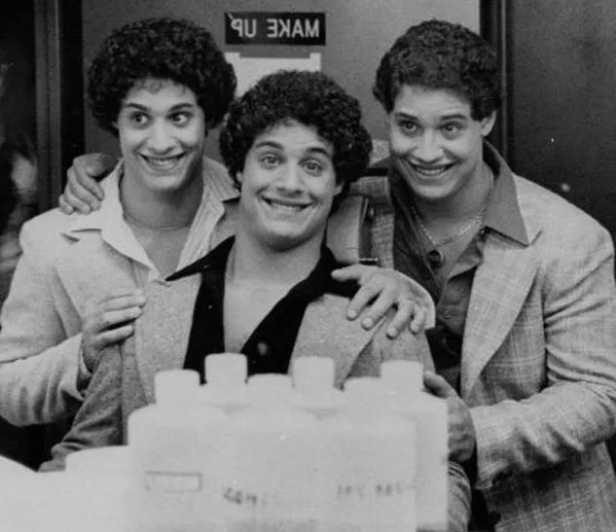

These triplets were separated at birth but somehow they continued to be connected and shared similar personalities. At the age of 19 Eddy and Bobby met and David saw the picture in the newspaper and contacted them immediately.

The reason why they were separated

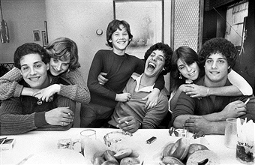

It was not destiny, they were part of an investigation, in which triplets were separated at birth but grew up in very similar environments. They wanted to see if that affected their personalities.

George Skrzynecky y Lucian Poznanksi
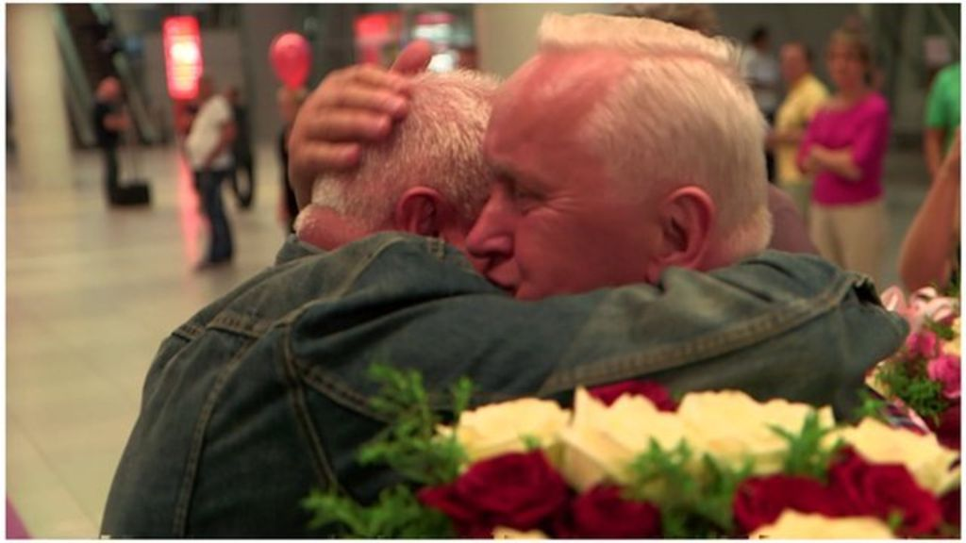

These twins were separated after the Second World War and they spent almost their entire life searching for each other until they finally found their missing brother. Since then they decided to spend all their life together.

Los mellizos Ingleses

These brothers decided to keep their identity undisclosed until they got married. They realized that they were twin brothers and had been separated at birth. They finally decided to annul their marriage. The identities were never revealed.

