Strange coincidences of history that will amaze you.

Coincidences can be defined by two or more events that with no explanation coincide. It has to even be difficult to understand how did those events happened in that specific way with no logic explanation.

We collect some of the most curious coincidences that have occurred throughout history, making us believe that destiny actually exists. Take a look at these amazing cases that will surely leave you a lot to think about.

Many things can happen in 365 days

Arvind Kejriwal is the name of this politician from India, and was reinstated to his charge exactly one year after his quitclaim. The possibility that this happened 365 days later is very unlikely, but it actually did.

As fleeting as a kite
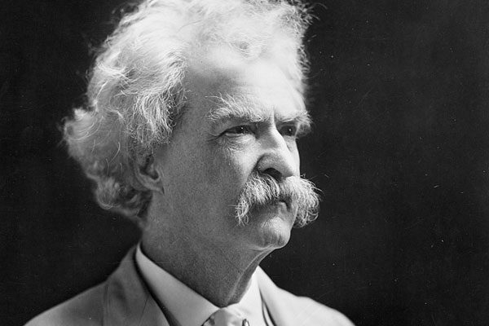

Mark Twain was born shortly after Comet Halley appeared in 1835. The coincidence was quite exact since several times he commented that he had arrived with it and would leave with it as well. On April 20, 1910, one day after the comet appeared again, he passed away.

All aboard

In 1906 a ship called "Grosser Kurfurst", which traveled from Germany to New York, was the place where several babies were born. The curious thing was the quantity and its order. In the first one a child was born, in the second a pair of twins, and in the third one a triplet.

Everything is written

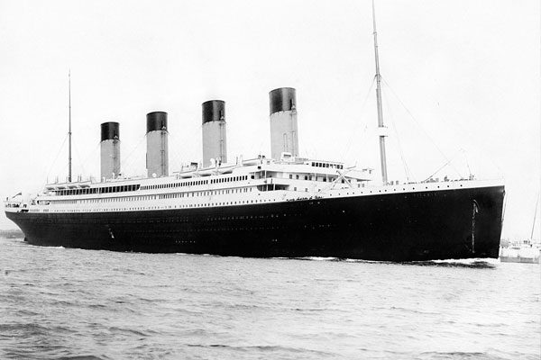

In 1898 Morgan Robertson wrote a novel entitled "Vanity", which told the sinking of a transatlantic Titan. Fourteen years later the Titanic sank.

Numbers that match

All these words are composed of 11 letters: New York City, Afghanistan, Ramsin Yuseb (name of terrorist), George W Bush, the flight was number 11 and this happened on September 11.

Details that warn us

Many remember Johny Bravo for being one of their childhood cartoons. In this episode, it announced an event that would happen 5 months later, a big accident in a tower. On September 11, 2011 the attack on the twin towers happened.

"1000 runs"

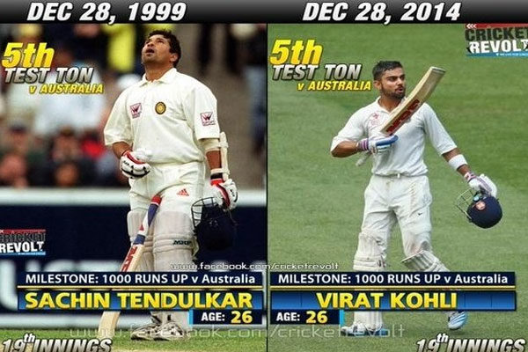

For the Cricket players of 1000 runs is a great milestone and these Australians fulfilled it, but on very exact dates. Achieving not only with the same team and at the same age, but also on the same date 15 years later.

Film similarities

This curious and a bit funny event happened in 1990 in a school in the United Kingdom, where several students performed standardized tests and the student named James Bond, as the character in the film, obtained the copy 007.

So similar

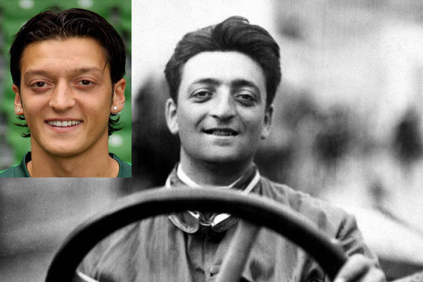

Enzo Ferrari, the founder of the car company, who died in 1988, is very similar to the player we all know today, Mesut Ozil, who was born that same year.

One character, two different countries

The comic "Daniel the naughty" was released at the same time in the United States and the United Kingdom by two different cartoonists without knowing anything about each other.

The Karma

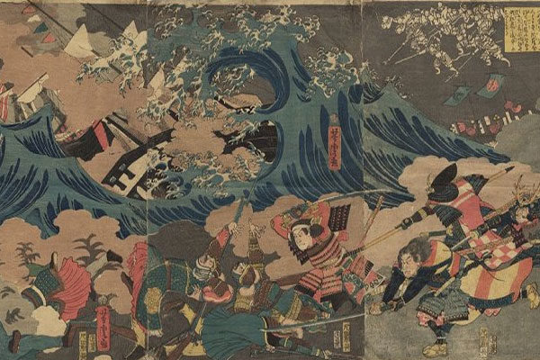

When the Mongols tried to invade Japan in the 13th century and a great typhoon stopped them, they decided to attack the following year. But a typhoon hit them again and they decided not to do it again since this culture believes a lot in karma and destiny.

Bad luck’s number

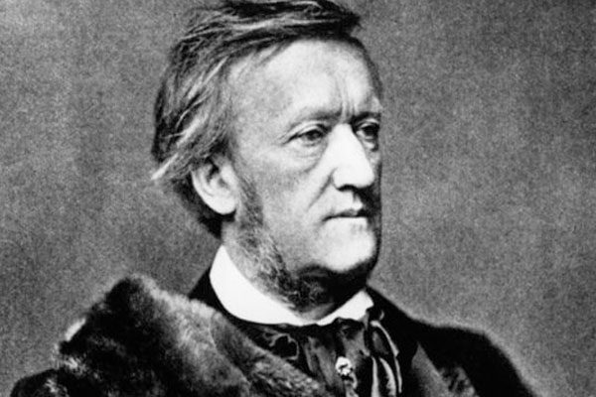

Richard Wagner was a German composer, opera director who was born in 1813. Apparently these last two numbers accompanied him throughout his life. He was banished 13 years of his life, his name has 13 letters, opened a place where he presented his music and works on August 13 and also died on February 13. Incredible, right?

129 years of difference

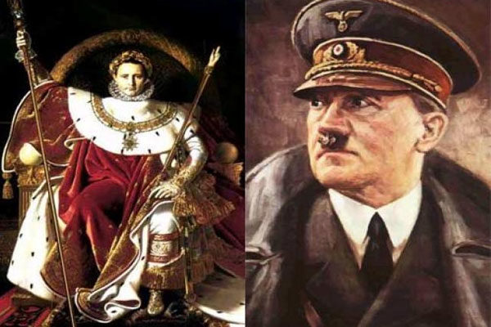

The parallelism of Napoleon and Hitler is impressive. Napoleon took power in 1804. Hitler in 1933. Napoleon entered Vienna in 1809. Hitler in 1938. Napoleon entered Russia in 1812. Hitler in 1941. Each of these three events happened with 129 years of difference.

The book came to him

Anthony Hopkins, the talented actor, won one of the leading roles in the film based on the novel "The Woman of Petrovka" by George Feifer, which he had not read. Days later, when he was on the subway he found the book abandoned in a seat that, coincidently, was the one he chose and was so surprised that decided to read it.

Very similar lives

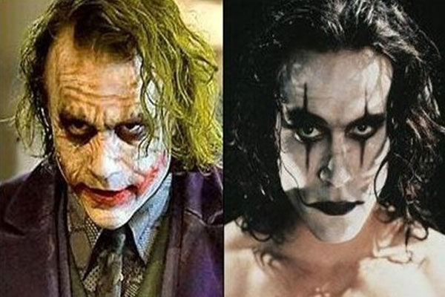

Heath Ledger and Brandon Lee were actors with many similarities, including divorced parents, both actors, teacher mothers and died at 28 years.

A dream come true

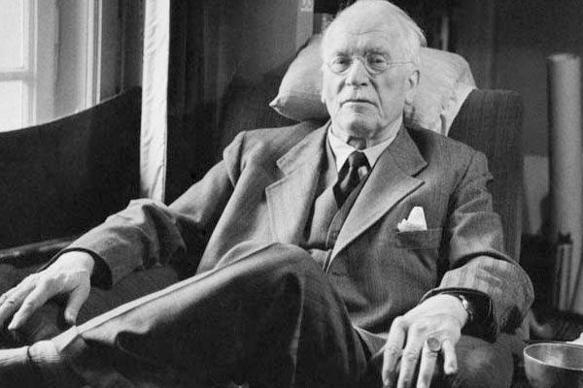

The Swiss psychologist Carl Jung, one of the fathers of modern psychology, had a very peculiar case with one of his patients. While she told him about her dream in which he gave her a golden beetle, an almost golden insect came through his window and it was placed in his hand. He was speechless and believes it was an unforgettable experience.

"Disaster prophet"

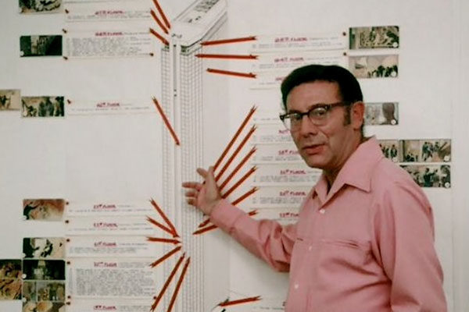

The film producer Irwin Allen made several films with many disastrous coincidences. One of them, was his film called "Hell in the Tower" since two years later three skyscrapers burned in Brazil.

Names that make us doubt

In 1974, at the "Pepperidge Farm" candy factory in Pennsylvania, one of the workers died by falling accidentally into a tank of liquid chocolate. His name was Robert C. H. Hershey, the same name as the famous Hershey family, founder of the largest and oldest chocolate company in the United States in the same city.

Exact numbers

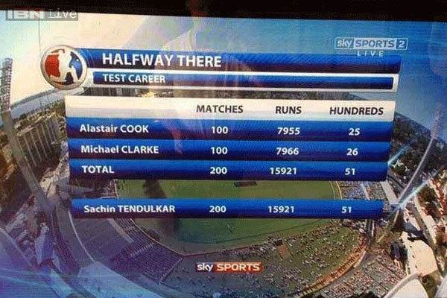

These results are very curious, since the first two are not only very similar but the sum of both of them turns out to be the result of the third.

Twin brothers

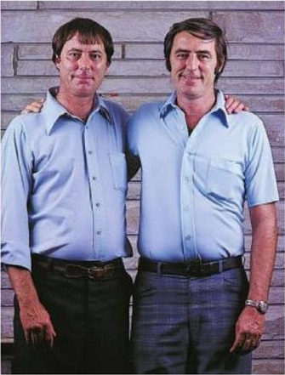

The twins Jim Lewis and Jim Springer were separated at birth. However, their families gave them the same name without knowing. Both studied the same career and married someone named Linda, with whom they had 2 children.

