Codes to find the movies and series on Netflix without looking too much, we'll tell you what they are!

Netflix is ​​a virtual platform for audiovisual content, and is one of the most important ones since it allows us to see a wide variety of series and movies without having to leave our homes. Although we have endless options, many times we waste time trying to find what to watch. Very few people know that there are certain codes and numbers attached to the URL of the site that you can discover which provides films and programs that are not visible on the platform. To access them simply put the code at the end of www.netflix.com/browse/genre/ <code>
Below we will tell you some codes that you can use to find some specific genres with a wide variety of movies and programs that you did not know existed. The only thing you must do is adding it to the link that we indicated before and you are ready!

Anime action, Code 2653
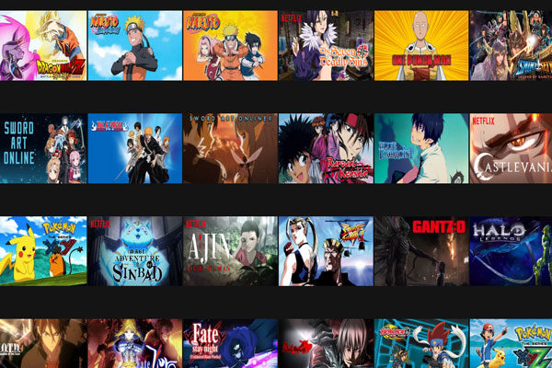

If you like anime, the only thing you have to do is log in to your account and add to this link https://www.netflix.com/browse/genre/2653, with this number at the end. You will be able to find a great variety of Choices from which to choose.

Superheroes and based on comics, Code 10118

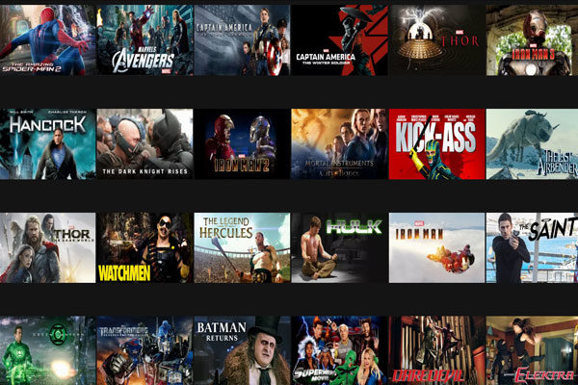

If you are a fan of comics and superheroes, the code 10118 will be perfect for you. Without having to search so much you will find movies with this genre which will make your choice easier. In this image we show you some that you will find.

Classics of action and adventure, Code 46576

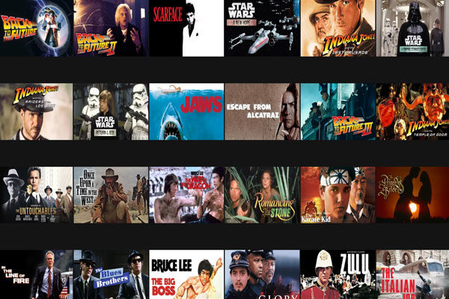

There is nothing better than classic and action movies, and this category includes: Star Wars, Journey to the future and Indiana Jones. If you like any of the movies that we show you in the image just add the code 46576 at the end of the link that we mentioned before.

Classic Comedies, Code 31694

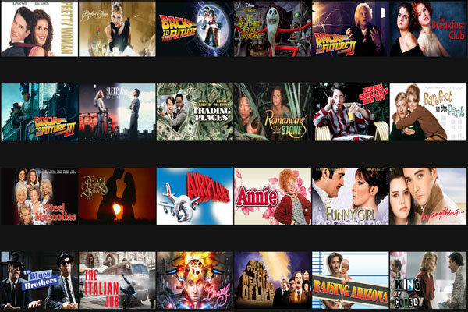

The comedies are also perfect for any occasion and these classics will make you come back in time and laugh a little. These are some movies that you will find and if you decide for any of them just add the code as we explained..

For children and family, Code 783

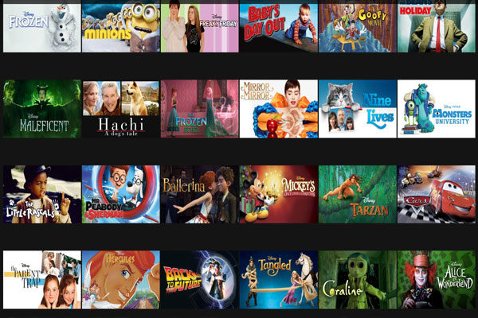

In this category you will find moving stories and a bit of comedy, perfect for a family night or an afternoon at home. If you liked “Hachi” and “Crazy Friday”, you would like this category. Just add the code at the end, https://www.netflix.com/browse/genre/783, like that and that's it.

Disney, Code 67673

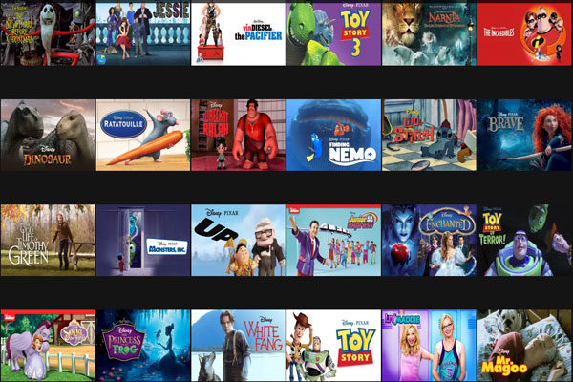

We all love Disney movies, no matter how old we are, we always come back to watch them again and again. These are some series and movies that you will find, some are newer than others. Take a look, there are many more options that will surely interest you!

Low Budget Horror Movies, 8195 Code

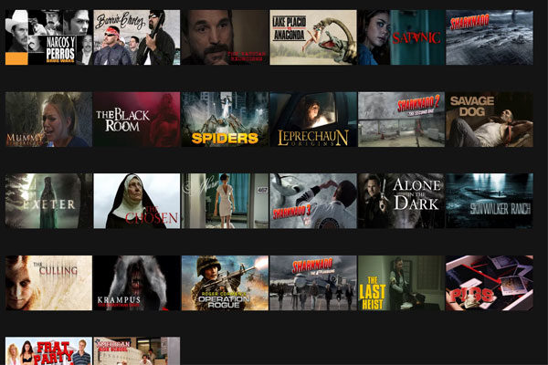

If you are one of those who like suspense and do not fear anything, this category has several scary movies but made with a limited budget, which makes them a bit more interesting and scary.

Horror Zombie movies, 75405 Code

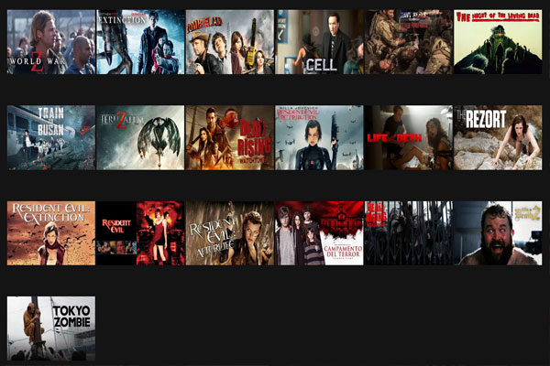

Zombie movies never go out of fashion and in this category you will find the best ones, some funny movies like “Zombieland”, and others of true suspense like “Train to Busan”. If you have not seen any of the ones shown in the image, go to this link https://www.netflix.com/browse/genre/75405.

Black humor, Code 869
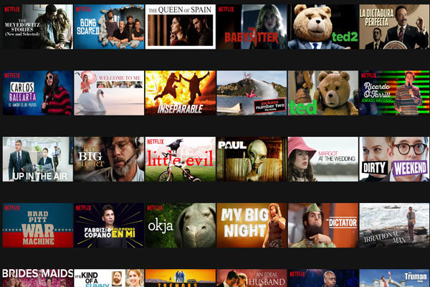

If you like sarcasm and a little heavier comedy, these options will please you a lot. Here you can choose between movies, standups and mini-series. The amount of options in this category is very extensive, surely you will spend a lot of time entertaining.

Crime and moral ambiguity, Code 7687

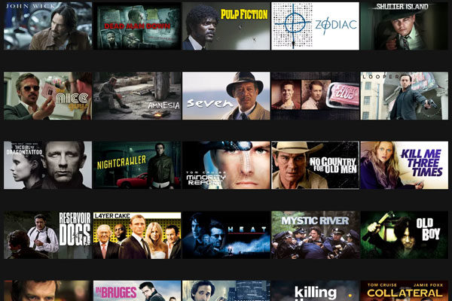

This category is known as Filmes Noir because they are movies full of suspense and crime in a deeper and psychological way. If you like this type of film you will surely recognize some of the films that are shown in the image.

Food and travel, Code 72436

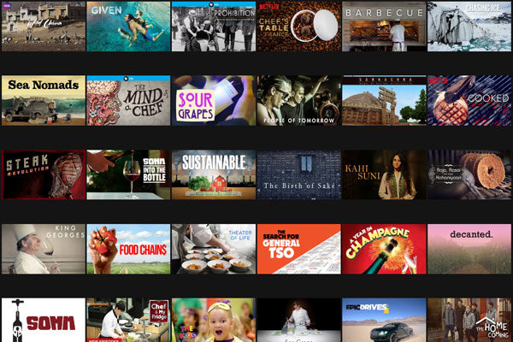

If you are passionate about traveling and eating, these films and documentaries will be sure of your interest. Usually you will not find or notice these movies when you log in to your account, but there are very good stories that will definitely catch you!

Children Television, Code 27346

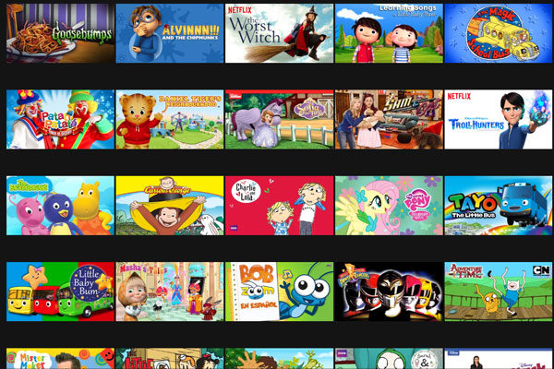

If you find yourself taking care of your siblings, nephews or children, this code is very useful to find any program very easily and keep them entertained with their favorite series. Best of all, you can see them without any interruption.

Korean Films, Code 5685

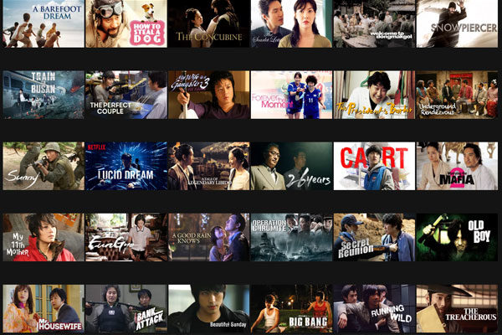

If you are one of those who like Korean cinema, this option will like you very much. Surely you never imagined finding so many movies on Netflix in this category. These films have incredible stories that manage to catch anyone.

Latin American Cinema Code 1613

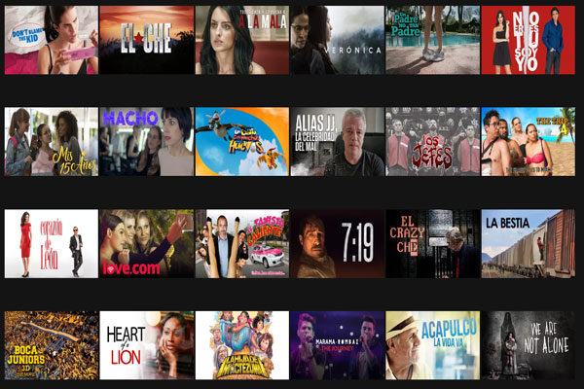

We all know that Latin American cinema is characterized by romantic and loving stories with a touch of comedy in them. If you like this type of movies, this category will help you choose your next option quite easily.

Music and concerts, Code 90361

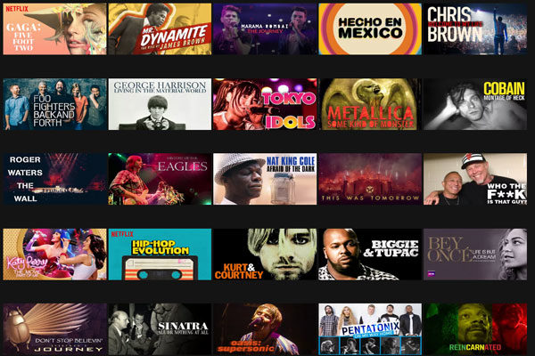

This category is perfect for true lovers of music and concerts. Here you will find your favorite singers and their best live shows, as well as some documentaries and real stories about their path to success. Just add the code to the link that we mentioned above and you will get a wide variety of options.

Musicals, Code 13335

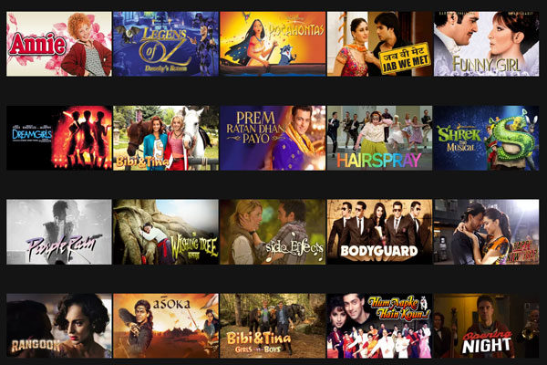

If your thing is to sing and dance, these musical movies will enchant you, and not only will you find Hairspray, there are many more options that you probably did not know but will definitely interest you, including the famous Indus movies.

Martial arts, Code 8985

This category is perfect for those who enjoy martial arts and fights. You can find a little bit of everything including Kung Fu Panda, Karate Kid and Matrix. Just enter this link: https://www.netflix.com/browse/genre/8985

Boxing, Code 6695

Like the previous category in this, you can find movies that deal with fights but boxing instead, which is a totally different discipline, from its movements to its rules.

Psychological Thrillers, Code 5505

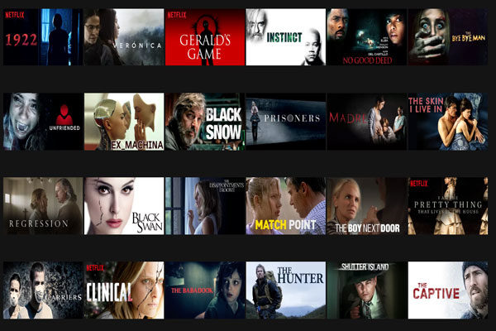

These films will not only make you paralyze, they will also make you question and use your head a little bit more to be able to solve all the mysteries. Not all of these movies are well known but they count on great plots.

More codes

Although in this list we could not mention all the categories available on Netflix, this link https://netflixcodes.me/ will give you more options and topics with their codes so that you can enter and find exactly what you are looking for.

