Best dog house ideas for your pet!

We love our little doggies. That’s why sometimes they just sleep with us, however, some of them have their own little house. They need to have some privacy too people! Well, most of you are probably thinking: “they can sleep perfectly on the floor”. The thing is we don’t want them to do that. We love them as if they were a big part of our family. That’s why we buy and do everything to make them happy. From little treats to houses so that they can sleep, or even drink their water. Here, we are going to show you some of the best pet houses.

Wooden

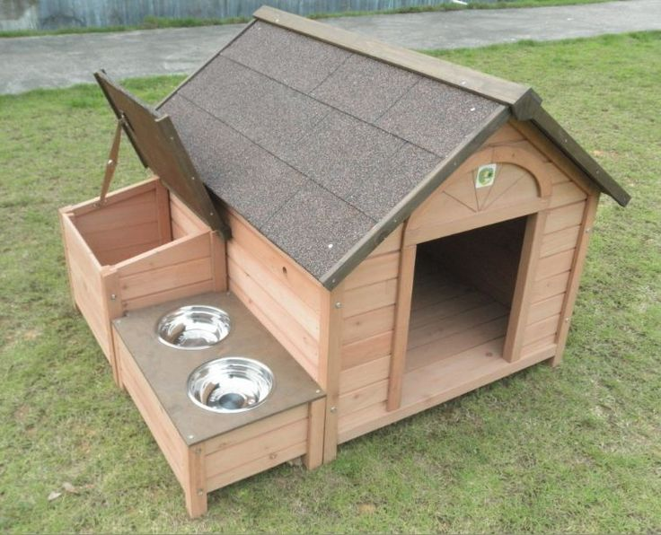

Wooden, comfortable and it even has two little water bowls. Cute little dog house, we can’t deny we all want something like this for our pet!

It has a room inside with real windows!

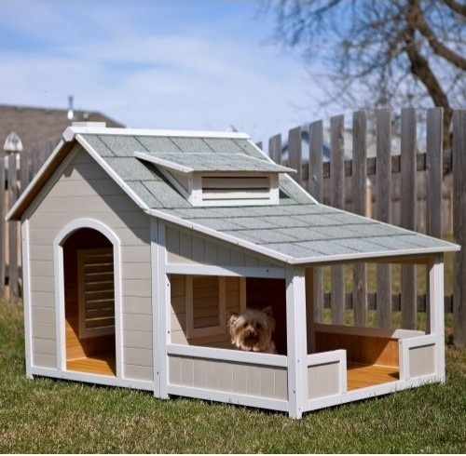

Luxury French dog house! Take a look at this one. That little dog looks so comfortable in its own place. So like: “ok, people picture it, it’s quite cool”. LOL. He can even enjoy the nature that’s around him.

Royalty dog

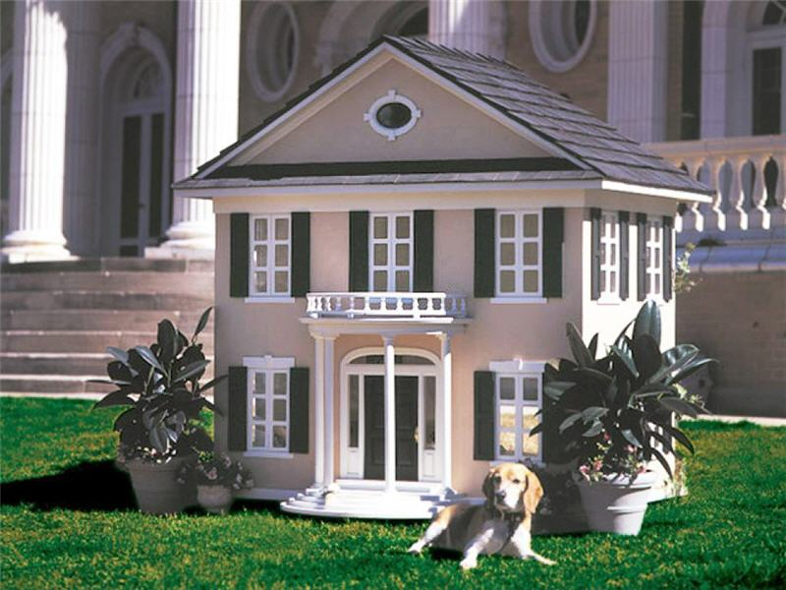

Do you remember Reese Witherspoon in “Legally Blonde”? Well, this is the best representation of that character. It’s the funniest thing I’ve ever seen. It looks like this dog is part of a royal family. As we can see there are also columns in the big real house so it seems to be a real copy of the family house but in the dog’s size! Amazing, right?

Lady’s house

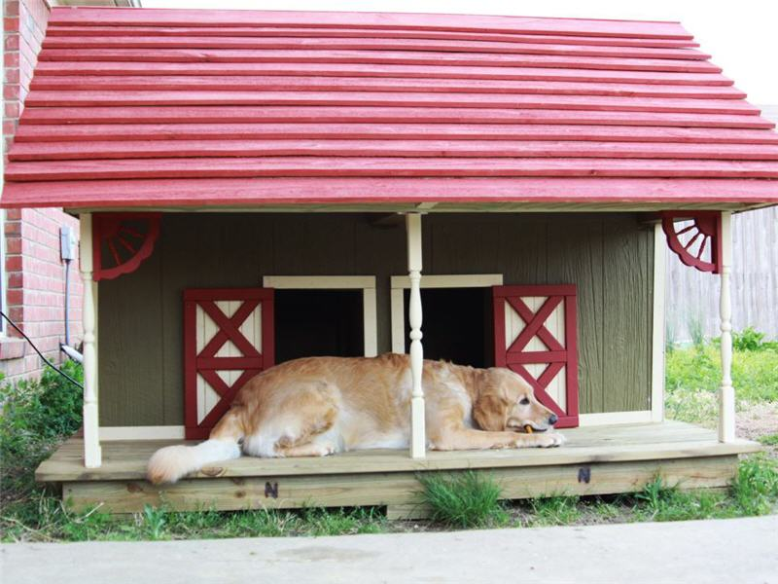

I feel like this one’s a little too small to that cute doggie. I mean his not the biggest dog I’ve seen. However, he is a little too big for those little entrances. Leaving that behind, I have to say it’s a cute dog house. It’s doors and little columns are just adorable.

Practical

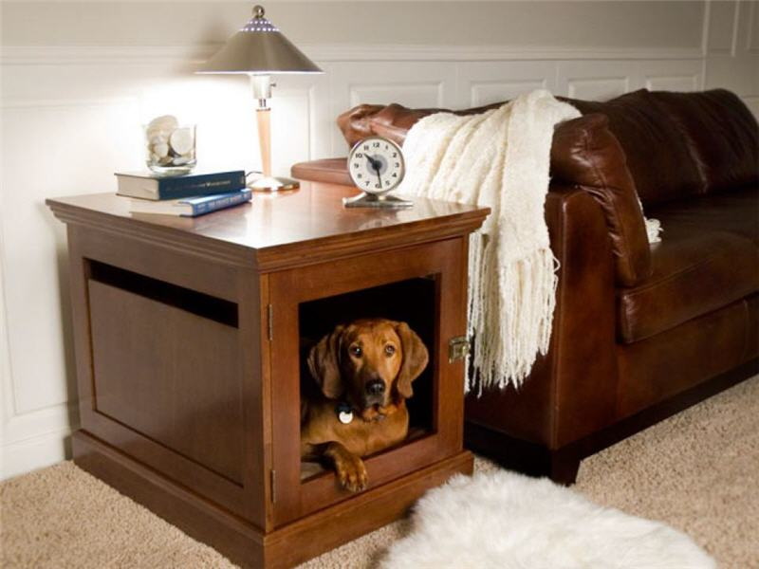

When you are so used to having them near, this is the best option! For little dogs that are also used to sleeping in small little places, this is the best thing you could ever buy them.

For big buddies!

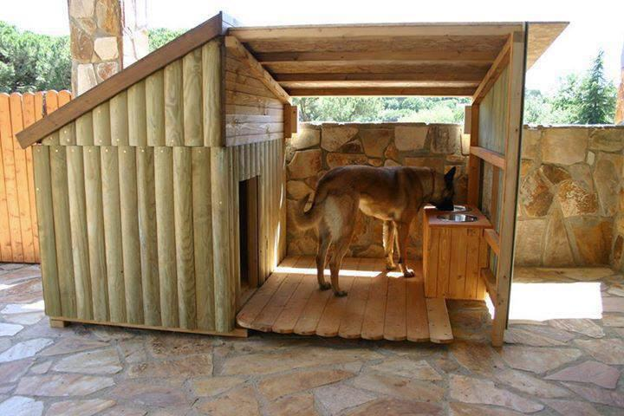

This one’s the other way around, there are some big doggies that have column problems so it’s difficult for them when it comes to bending over to eat or drink form their little plates. Boxer doggies are one of the most common dogs that suffer from these, so I strongly feel like this one’s one of the best options, bring them their food closer!

Jail

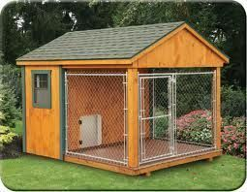

I hate this one! It really looks like jail. If you want to lock your dog somewhere don’t buy a huge place just lock them inside or please don’t buy a dog, they have to be free to run whenever they want. They don’t deserve to be locked anywhere!

Little cute space

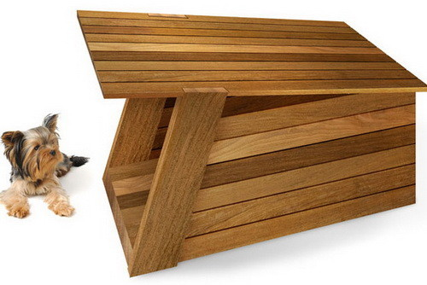

This one’s just something to put in your room if you don’t want them to be on your bed. It definitely looks like furniture. You can even attach it to your bed or wardrobe and it’s ready!
Perfect for detachments. Your doggie will sleep near you but not inside your bed!

Friendly!

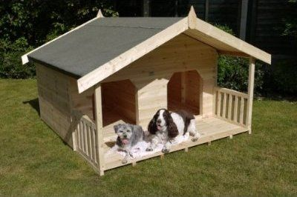

If you don’t have just one dog, this is the best solution. It is like a regular dog’s house but with a partition in the middle so it has the same things but twice. Each of them have the same things and jealousy’s out!

Mushroom!

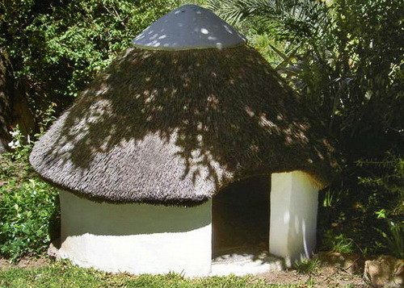

Modern dog’s house. This one something like a big igloo but in the shape of a mushroom and for dogs. I simply love it; it looks really cute!

Fine villa

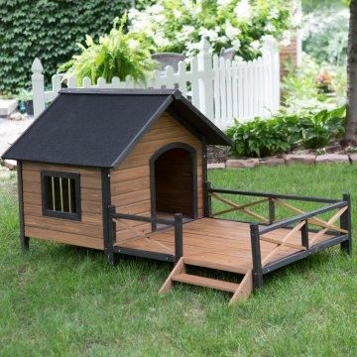

This one looks like a fine place for your doggie to sleep in. The black details give a cool little touch to this house look. Pretty cool, don’t you think?

Triplets

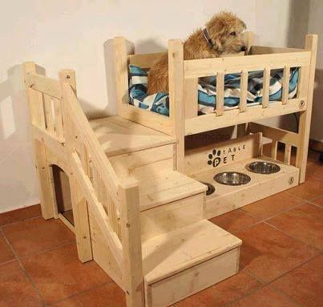

Look at this one! It had 3 little bowls. It also has space going up the stairs for one dog to sleep, under that it also has two more spaces where other two doggies can get comfortable and take the best nap in the world!

Outdoor

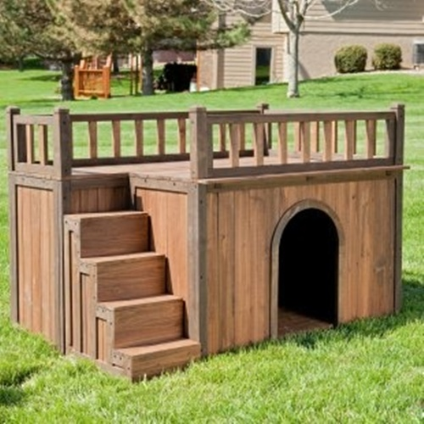

This one is for your park. It has a little place where your dog can also be inside and rest from the sun. However, it was thought as a dog terrace! They also enjoy the sun so this is one could be a good place to take a nap while enjoying the sun.

Fish and dogs

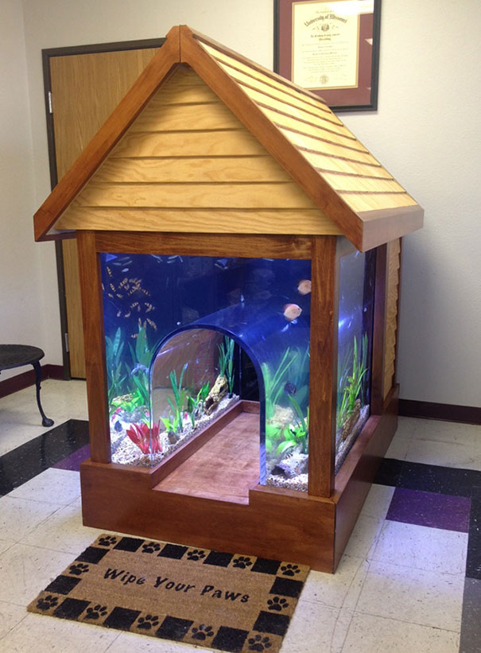

Could you imagine that your dog’s house could have a great aquarium inside? Well, if you didn’t look at this great idea. I think is one of the coolest.

Modern ones!

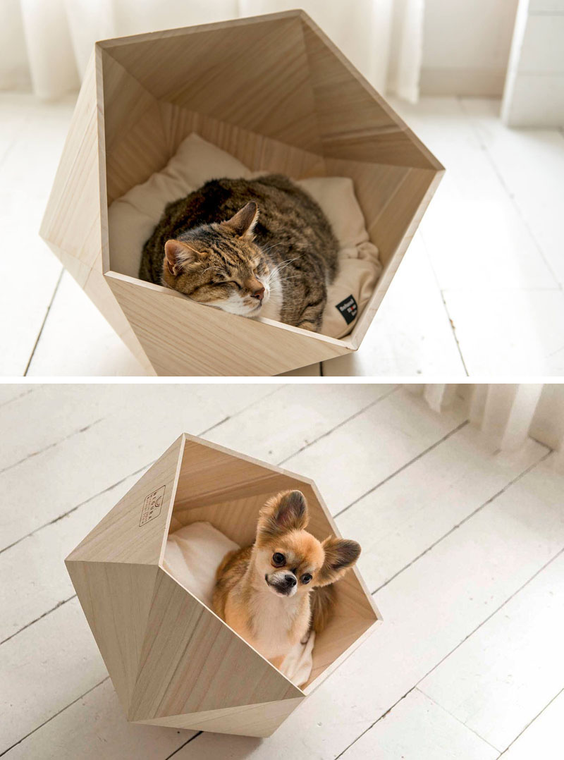
The indie cool new geometric idea. I mean, if there were different styles in dog’s lives I would say these doggies are the coolest dogs in the whole world. Look at those new age geometrical houses. Uncomfortable but the coolest thing around.

Christmas eve!

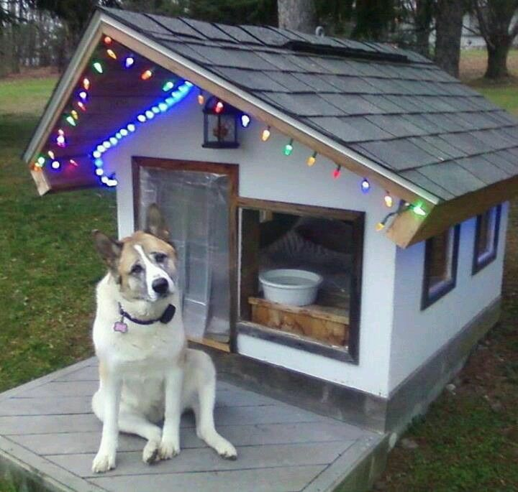
Why not decorating your dog’s house too? I mean it is Christmas for them too. You should have in mind that they usually are afraid of fireworks so these are their “safe places” when loud noises appear. Help them having a sweet and holy Christmas!

Sponge Bob’s world

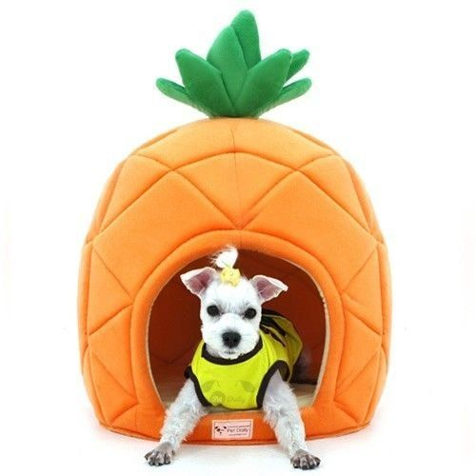

This one is so cute I can’t even describe it! Look at that little ponytail. She doesn’t have any hair at all LOL. That little space looks quite comforting; it definitely looks softer than the luxurious one not to bring up it’s cool colors!

For cool little ones!

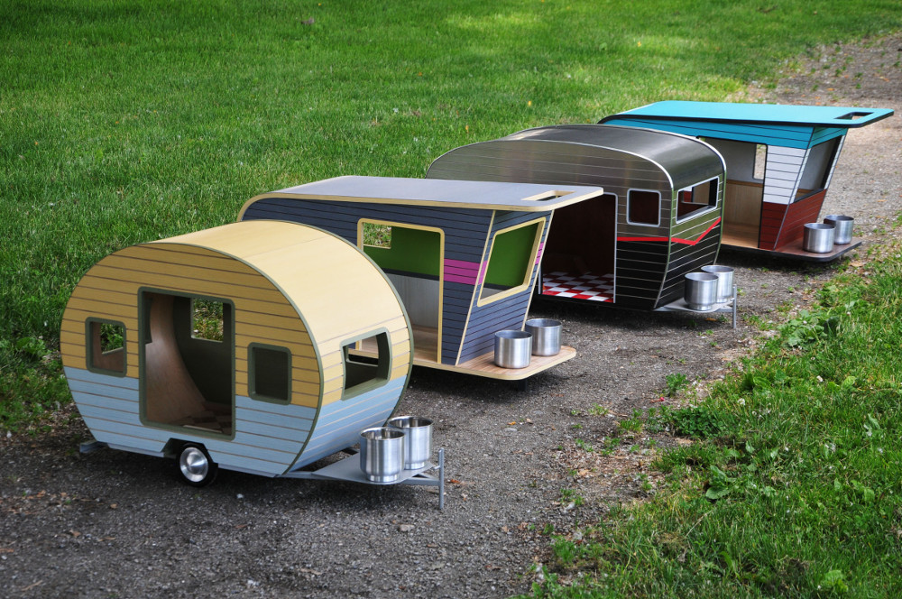

OMG! This can’t be real. I love them! I even want one for myself. Well, I’m exaggerating a little bit. However, I feel like it’s the coolest thing ever for your dog to have.

Cool labyrinth

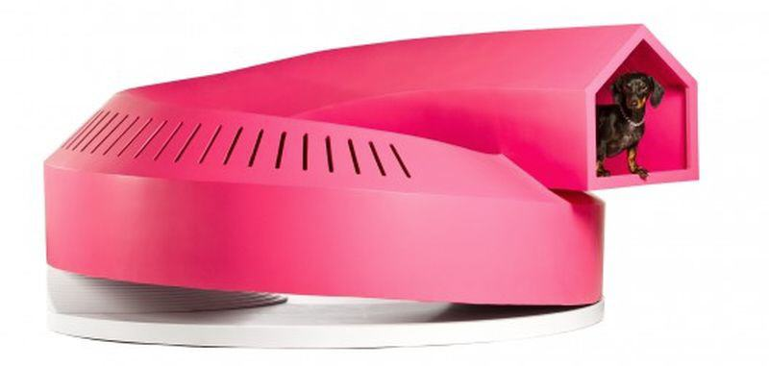

Girly, fuchsia, great thing for your dog to play with. It’s a cool labyrinth to place wherever you like. It’s stylish so it’s not difficult to decide where to put it.

Plastic

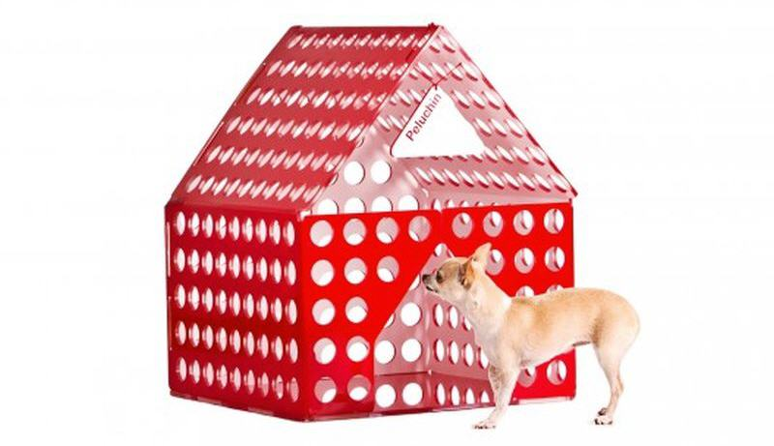

The cool thing about plastic is that you can move it from one place to another quite easily. It’s better to use bright colors. Yellow, red or green are great options for this house.

