Best babies after eating lemon reactions!

Babies are always funny. Not only because they don’t know how to talk or communicate but for the simple fact that they are knowing everything for the first time which is something we sometimes forget. Do you remember the first time you tried the sourest food in the whole world? What was your reaction? Did you like it or did it bother you? Well, here we gather the best baby faces after trying lemon for the first time. Hope you laugh like I did!

- Disgusting

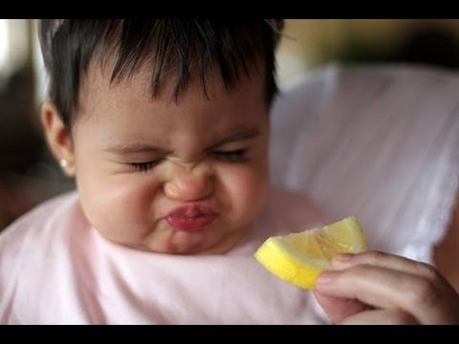

This baby can’t be more adorable, look at her chicks. I just want to hug her and give her lemon everyday. LOL!

- Chinese version
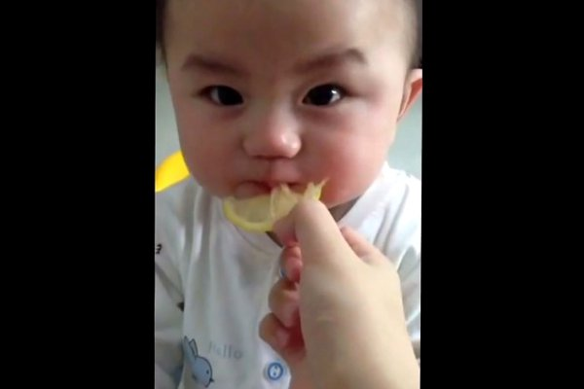

Ok, he thinks he can deal with it. In fact everything’s good, not sour at all. Who thought I would react differently?

I think maybe they were right, this is not good at all. I honestly don’t like it people!

OMG! This is disgusting. Mother and father, you are not being funny at all. Take this thing away from me please!!

5. I kind of like it!

This one’s not having the best time. However, he seems to like it a little bit. Don’t you think? So cute!

It is not funny

OMG, this baby can’t be having a worst time. Quite different to the last one, right? Poor baby, stop making fun of him. His discovering a whole new world on flavors and of course sourness.

Cute!

Oriental babies can’t be cuter!!! I mean look at this one. I definitely want to hug him non-stop. His hair and little hand made my day.

Angry or sad?

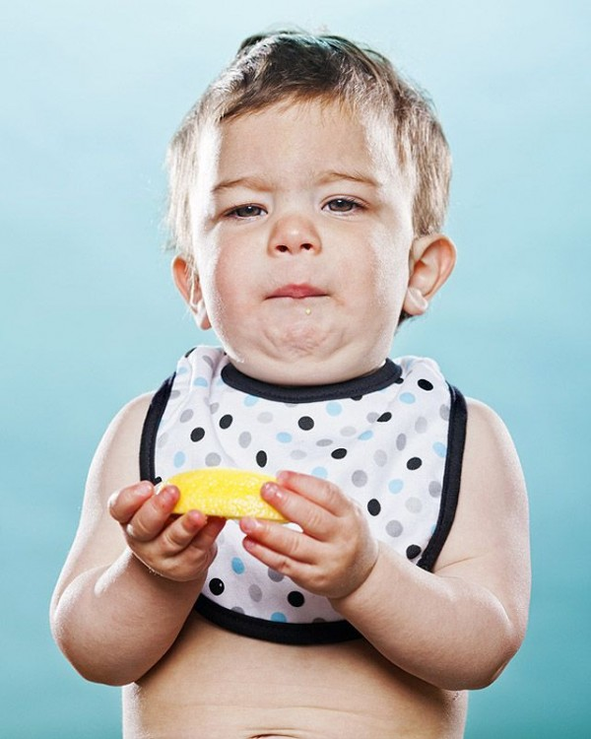

Take a look at these one. He can’t even decide how he is feeling. I can put myself inside of his head. “Is this good mmmm maybe no. No I honestly don’t like it”. LOL.

Best picture in the whole world

OMG. This baby!!!! I can’t stop laughing. Really? I honestly, didn’t know a baby could deform its face like this. It’s perfect and so funny I can’t even look at it more than once.

What?

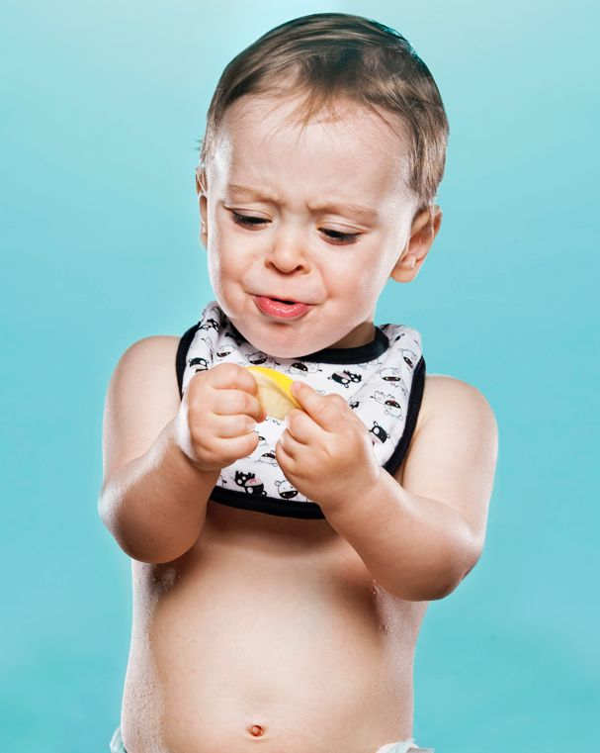

“What on earth did you give to me!?” “Please throw it away, far away from me and my mouth!”
Gimme more, honey!

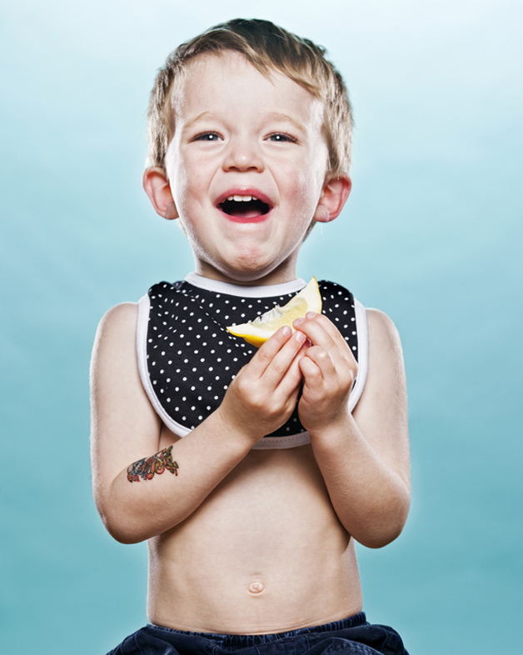

“This is the weirdest thing I have ever tasted. I love it please I want some more mommy!”

Rock’n Roll
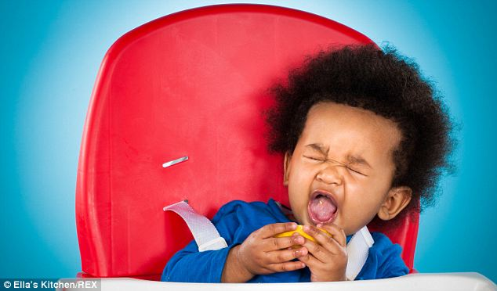

Rock’n roll family! This one loves it, crazy hair, crazy vibes. He definitely loves lemon and its sourness.

Confused princess

All right, this one’s just so grumpy, she can’t even bare the fact that someone has given her all this disgusting feeling.

What did you do?

This one’s like “OMG WHAT DID YOU DO TO ME!” I can’t believe how funny baby reactions can possibly be.

Stop it!

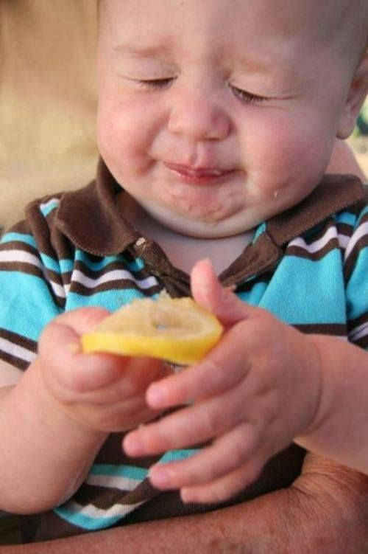

“I can’t stop the feeling!” It was not Justin Timberlake this time. it was this cute little baby thinking of his lemon reaction.

Lime

“Lemon or lime just take it away from my mouth people! This is not cool!”

