20 non-typical things to do in New York!

Who doesn’t love New York? I mean it’s a “concrete jungle where dreams are made of” if you ask Alicia Keys. Beyond these, it has everything: fashion, interesting museums, times square, central park! It’s a great mix between fresh air and crazy city lifestyle. It’s one of the most artistic cities I’ve ever visit, some museums are simply amazing not to mention Broadway. What could be more astonishing? Here we are going to share some of the non-typical things to do in New York, hope it helps you!

- BAR SIXTY FIVE – ROCKEFELLER CENTER

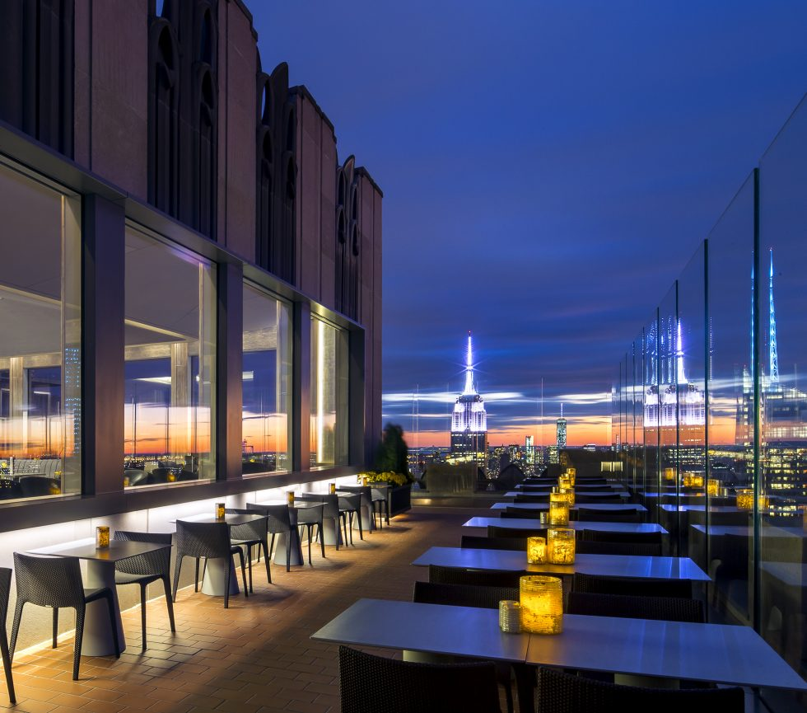

You don’t need to pay a ticket to enter and you have this amazing view! Drinks are not that expensive so it’s completely affordable. Each of these desks are next to a big glass wall that allows you to just sit there, relax after work and watch that amazing view.

- OLD RABBIT CLUB

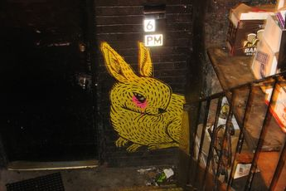

Cool bar in New York. What could be better? If you are a beer lover, a student that wants to relax after your exams or even a young professional this is the right place for you! Came hang out with your friend and enjoy cool music.

- Library way
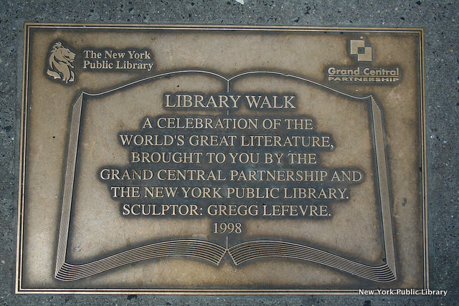
On your next trip, you can’t miss the main building of the fifth avenue. You should take 41st street where you can stop to read some inspirational quotes about reading and writing. You’ll have the best view of this building while reading the most beautiful things in the world!

- Lalo Café

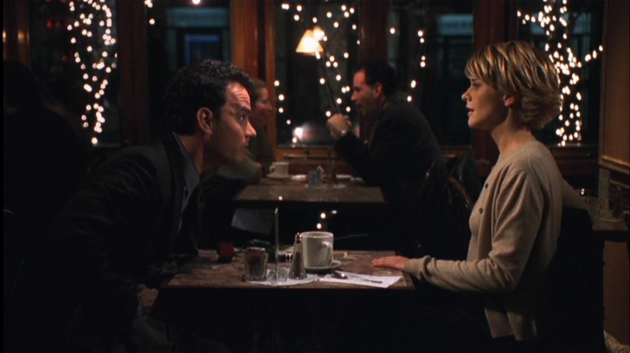
If you’re a movie lover, check out this one! You probably know “You’ve got mail” starring Tom Hanks and Meg Ryan. Well, Lalo café’s scene is millennial! Just see it by yourself. Remember now?

- Staten island ferry at night
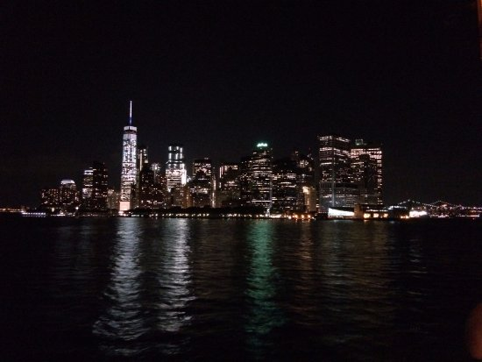

OMG this view is incredible. The Staten island ferry is a free New York cruise where you can enjoy skyline’s view at night. Imagine all those lights live right there near you. One of the best excursions you can do.

- Levain Bakery
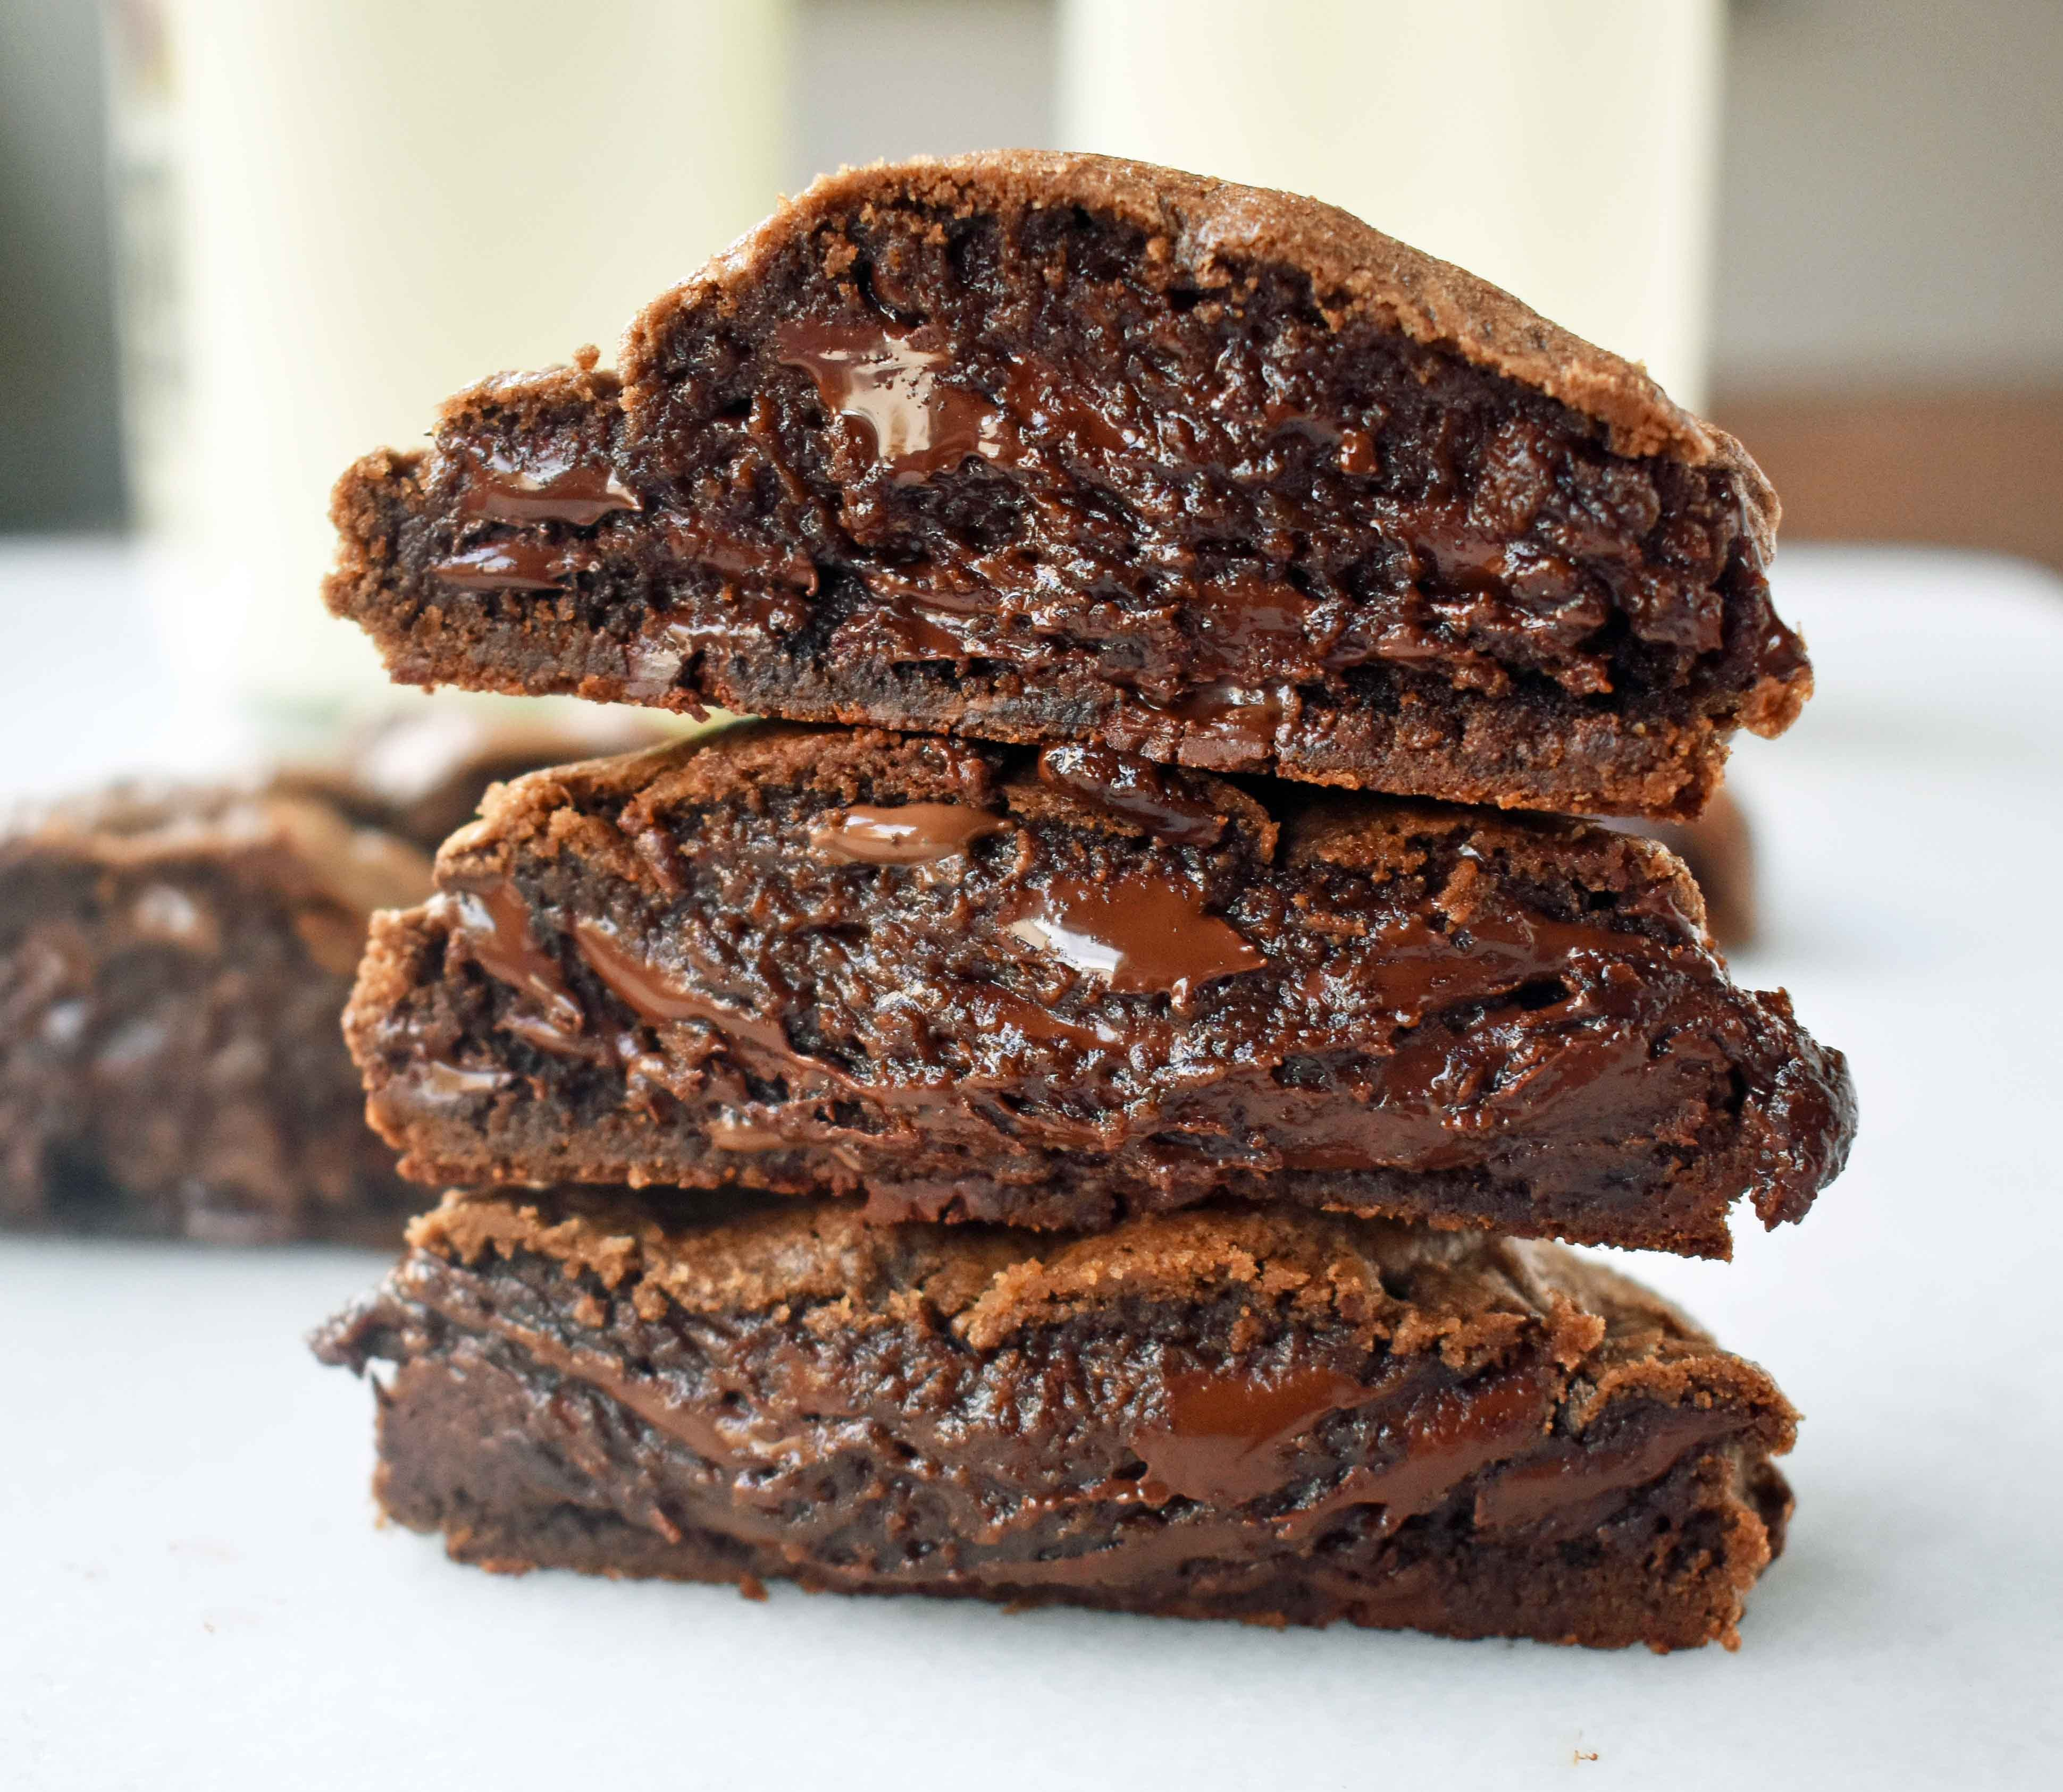
Upper West = Levain Bakery. Best cookies in the whole world. If it’s winter, you should also try them with hot chocolate or something hot. I can’t even describe that feeling. Just look at them omg!

- Cross to New Jersey
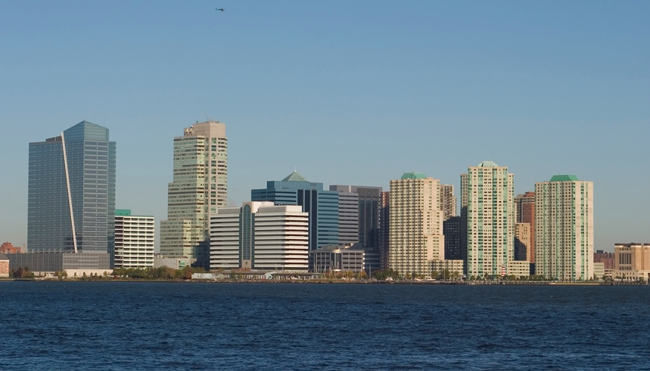

To have the best day views of Manhattan, you should definitely cross to Newport NJ, it’s only 5,50 USD and you’ll enjoy it and remember that for the rest of your life without any doubt.

- The View
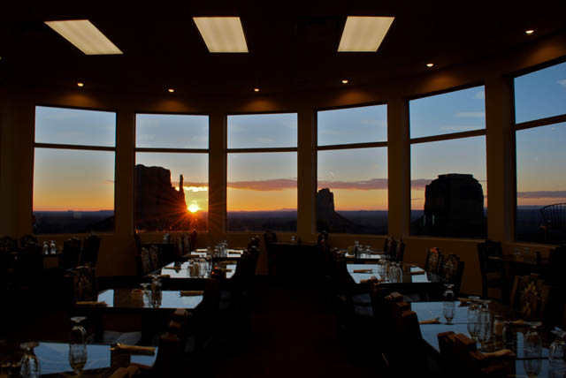

Rotary New York restaurant in Manhattan’s Marriot Marquis. I would personally prefer something more static. However, I’ve heard really cool things of this place.

- AQUA SANTA.

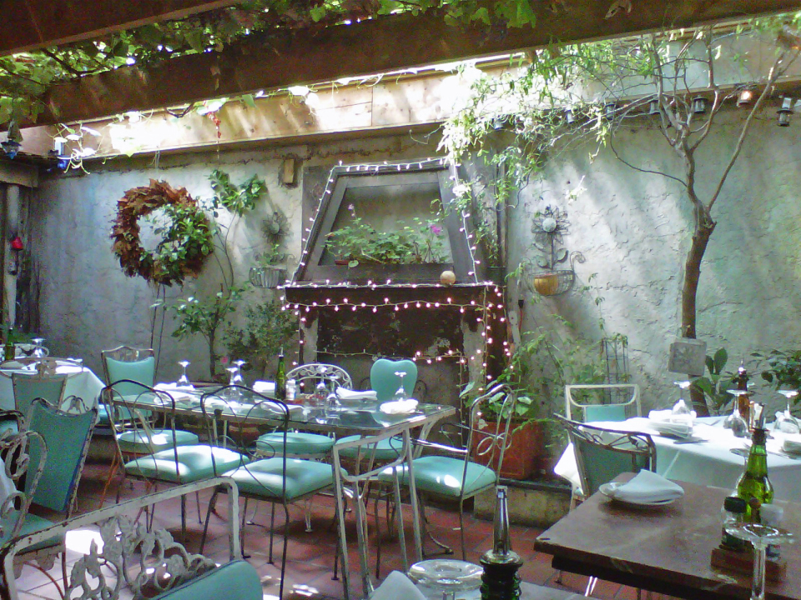

If you are looking for a great cheap place for dinner. Here’s the solution. Aqua Santa is located in Brooklyn and you can enjoy your meal smelling green while sitting under a plant sealing. It’s simply beautiful.

- Best souvenirs on earth!
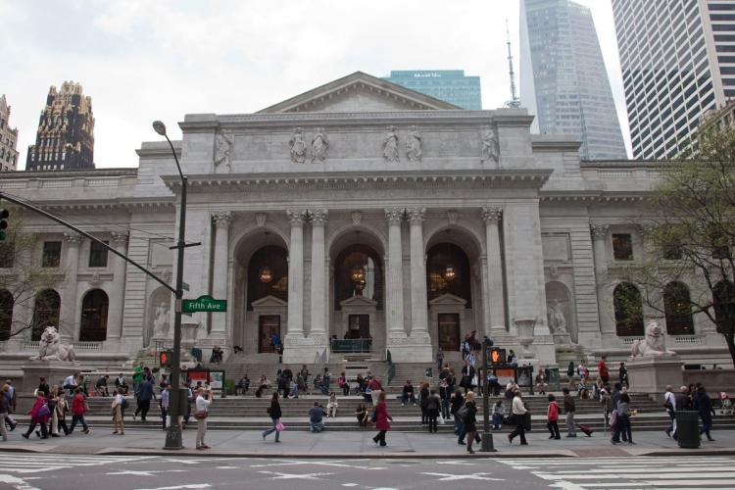

Here, the one and only New York Public Library. This is a great place to visit, even though it can sound boring, you can find the best souvenirs in here! Interesting and beautiful place to go visit, stay for a while, read a book and buy some gifts to take back home.

- Governor’s Island
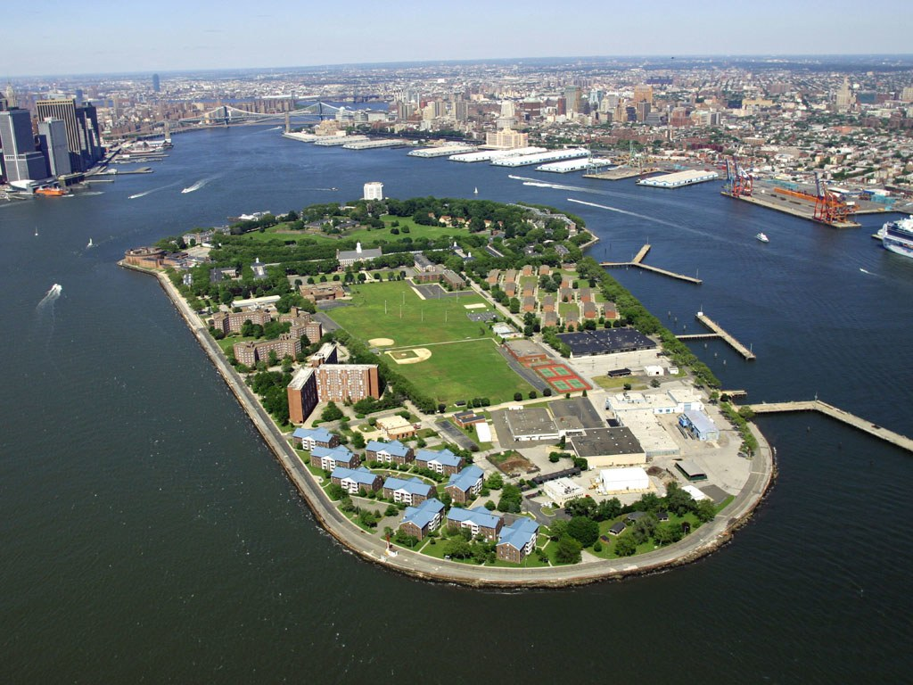

Did you know this was a former military base that turned into a public park? It’s just a short ferry ride from Manhattan. You can’t miss it! One of the coolest places I’ve been. It’s for sure quite different to everything else you visited.

- Martha’s (Williamsburg)
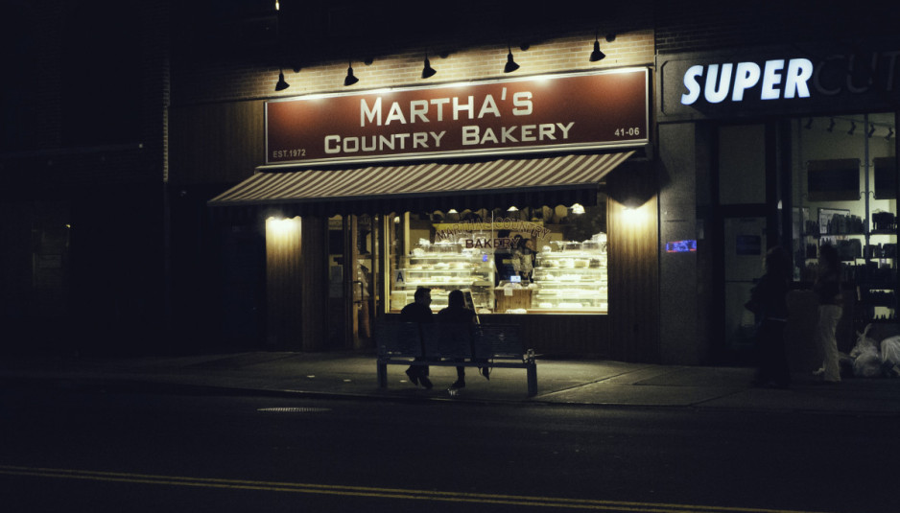

Regular customers just love this place! Martha’s bakery has every pie you can possibly imagine. And it’s not only the variety, it’s the quality of the food what customers love. Hostesses are just thinking in helping the customer have the best experience they can, and you know what? It actually works perfectly!

- DBGB Lower East Side
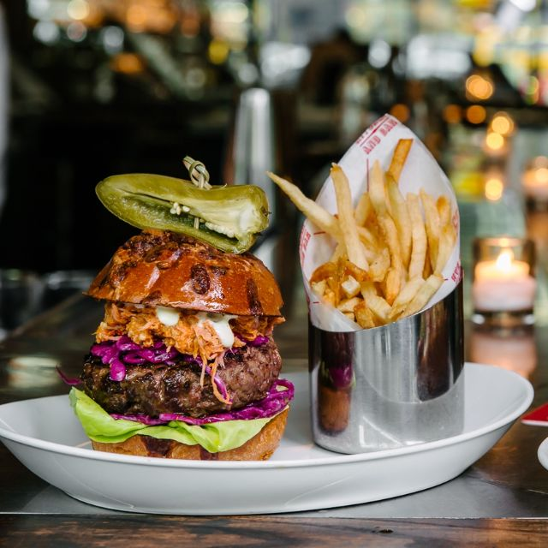

Best hamburgers in town! I know fast food is one of the most common things in the US. However, there are some places that are simply incredible. This hamburger got me like OMG. I just wanted to show it to everyone. You can’t possibly miss it.

- Trinity Church museum.

When you go visit Trinity church, you can’t miss the little museum that’s in there. It’s quite interesting even though it’s not a very well-known activity to do downtown. We can’t leave the church aside without saying anything about those windows. OMG, they are just magical.

- Stone street
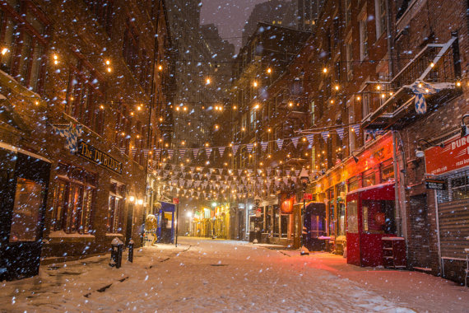

Snowing, in summer or whenever you visit NYC. You can’t miss Stone Street! Beautiful to have a drink. I personally recommend you to go on summer and grab a drink on the street. However, look how beautiful it is when it snows! Your choice. This place is beautiful anytime.

- Federal Reserve Tour.
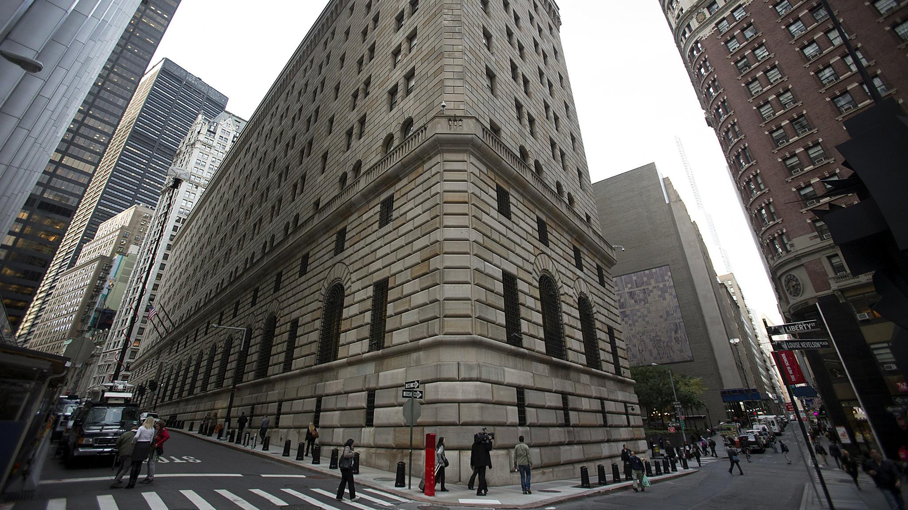

Interesting, free attraction that few people know in NYC. Visitors will learn a lot about the roles and responsibilities of this place. Really cool place for tourists. Try to go visit!

- Automatic cupcakes cashier.

Cupcake obsession right here! For all those fans, check this out. Cupcakes cashier. Instead of money, your favorite treat. It’s located in Upper East Side and it’s girly and pink. What could be better?

- Sutton place garden
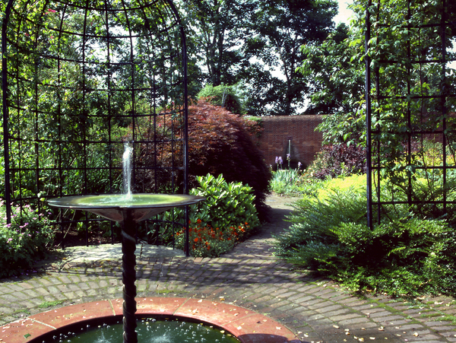

Look at this garden! It looks as If it came out from a movie. Magical and beautiful. Central Park it’s not the only green place you can go visit in NYC. There are places like this one you don’t know and can’t miss.

- Staten Island Ferry

You can enjoy the views from back across the Lower Manhattan, not only as a mine of transport to go visit the Statue of Liberty, but grabbing a beer, being on board and just enjoying New York City’s breeze.

- Guggenheim Museum.

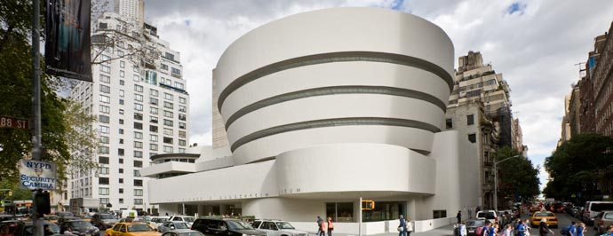

This museum is not as well-known as the MoMa or even the Metropolitan Museum. However, this building is simply astonishing. You won’t believe the architecture as well as the art work it has inside!

