20 healthiest foods of all time

Sometimes we think eating healthy is being on a diet. However, there are some things that are not specifically to lose weight but helps your fitness. Actually, studies discovered that some types of vegetables can even change your sense of humor. For example, eating too much grapefruit can get you down and also make you feel blue. Discovering yourself means also paying attention to your eating habits. I promise you’ll feel much better trying to add some of these to your feeding. Your body will receive it gratefully.

- Coconut oil
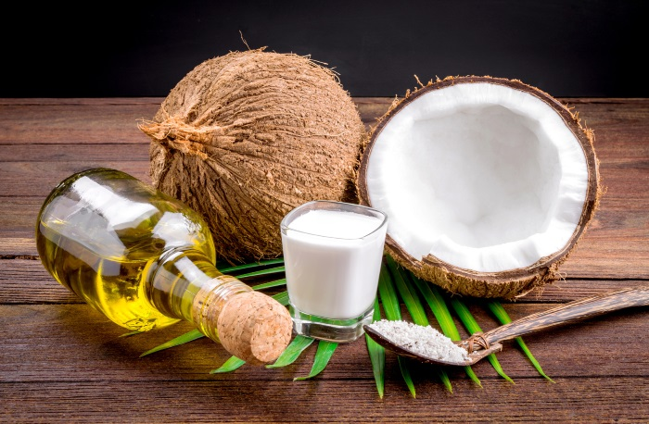

Perfect for your body’s metabolism. You can also make milk out of it that tastes great with any sugary dessert. Adding a little bit of coconut to salads is also a great way of starting eating it. You should definitely try it.

- Nuts
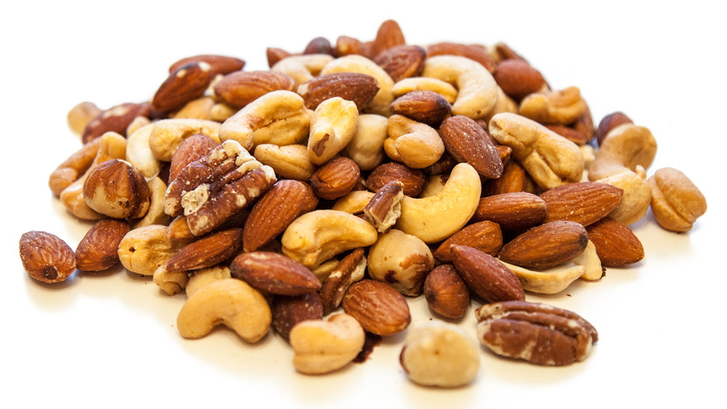

There are some studies that say that nuts help you live longer. I don’t know if I believe it, however I must say, they bring you great energies to start your day. They also helps you concentrate!

- Sweet potatoes
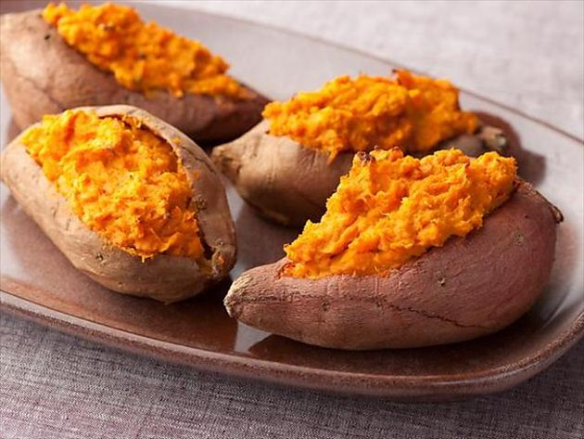

They help preventing heart disease and cancer, this is because they help regulating your blood sugar. They are great with cheese or even with some olive oil, pepper and salt on top!

- Sardines

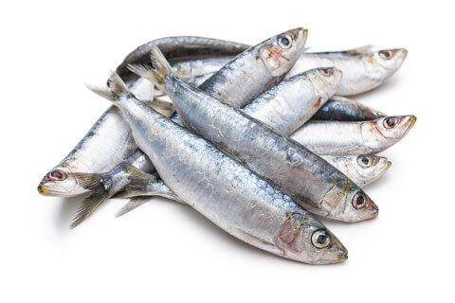

They have a lot of different nutrients that help your body. I’m definitely not a fan of them, however, there are lots of people that loves this fish! Some of them even add them to their pizza!

- Olive oil

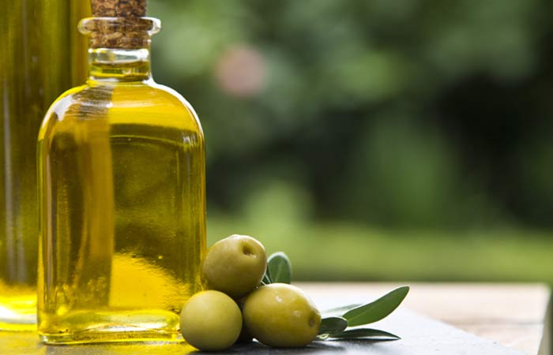

Olive oil some of the greatest things on earth! Everything tastes good with olive oil on top. Salads, potato, sweet potato, almost everything I would say. It helps your blood control too which prevents you from diabetes.

- Brussels Sprouts

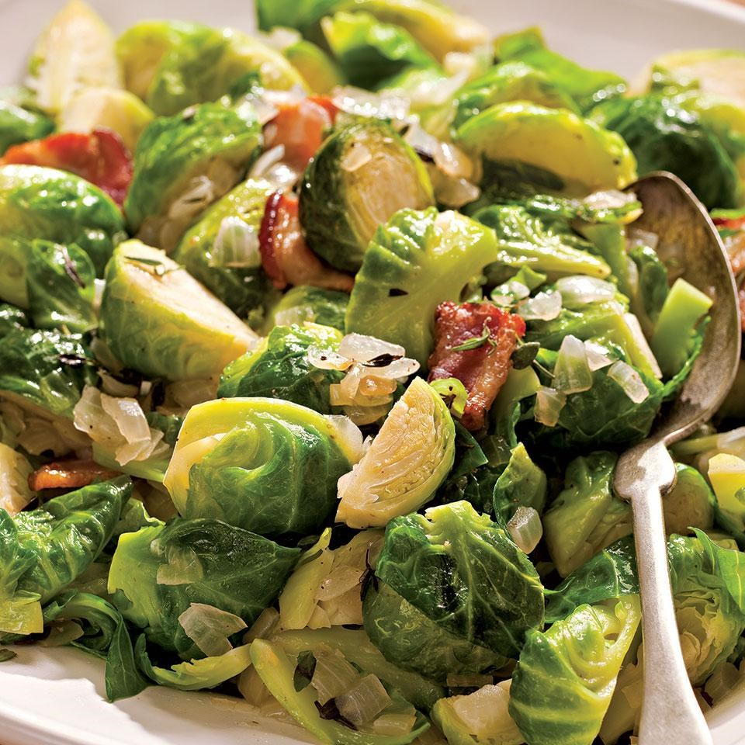

Brussels sprouts are perfect boiled or even inside your salad! It also helps preventing a lot of different diseases like cancer for example. I am a huge fan of them!

- Kiwi

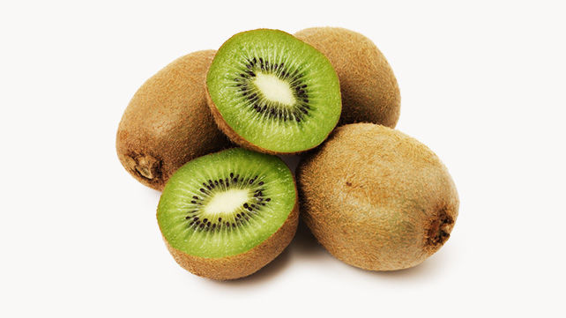

I hate being allergic to them because it is my favorite fruit on earth! They are an excellent source of antioxidant vitamins.

- Pomegranate
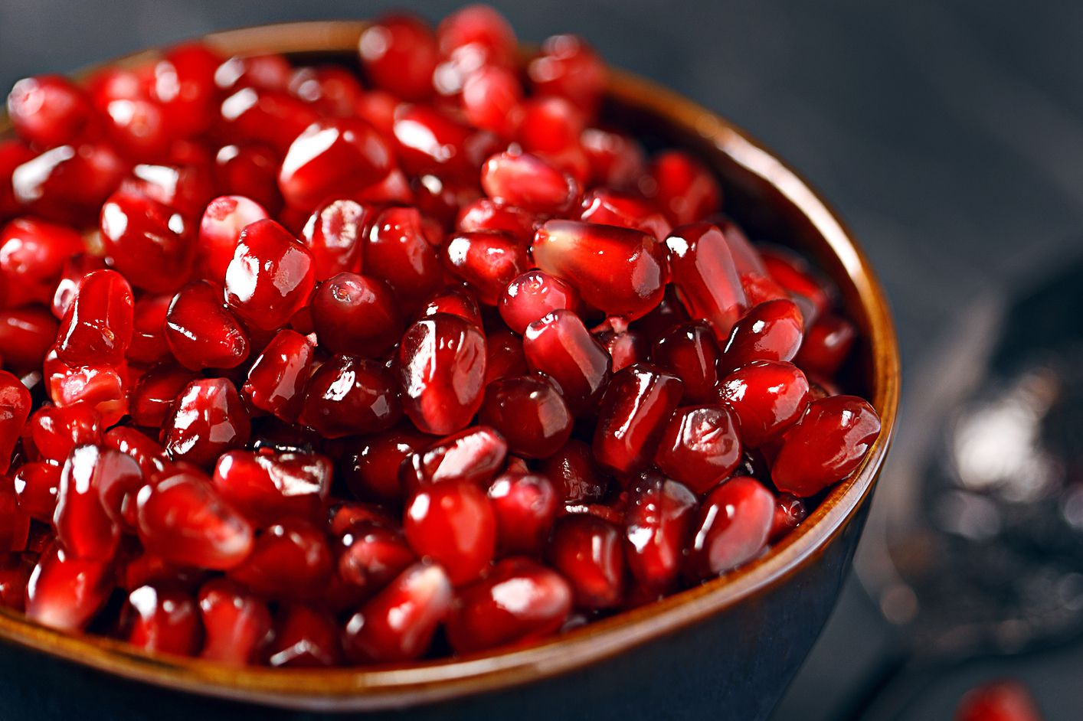

Nothing better than eating pomegranate on a hot summer afternoon. It is great to make cool juices! It helps your body’s stiffness! If you suffer from these, this is the answer to heaven.

- Blueberries
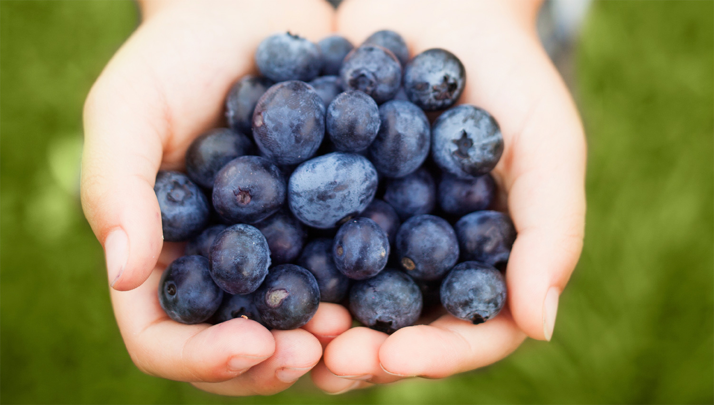

You can definitely eat them on the go, or perhaps with some orange juice on top. Perfect for preventing body aging as well as inflammatory intestinal conditions. I simply love them, small, tasty blueberries

- Raspberries

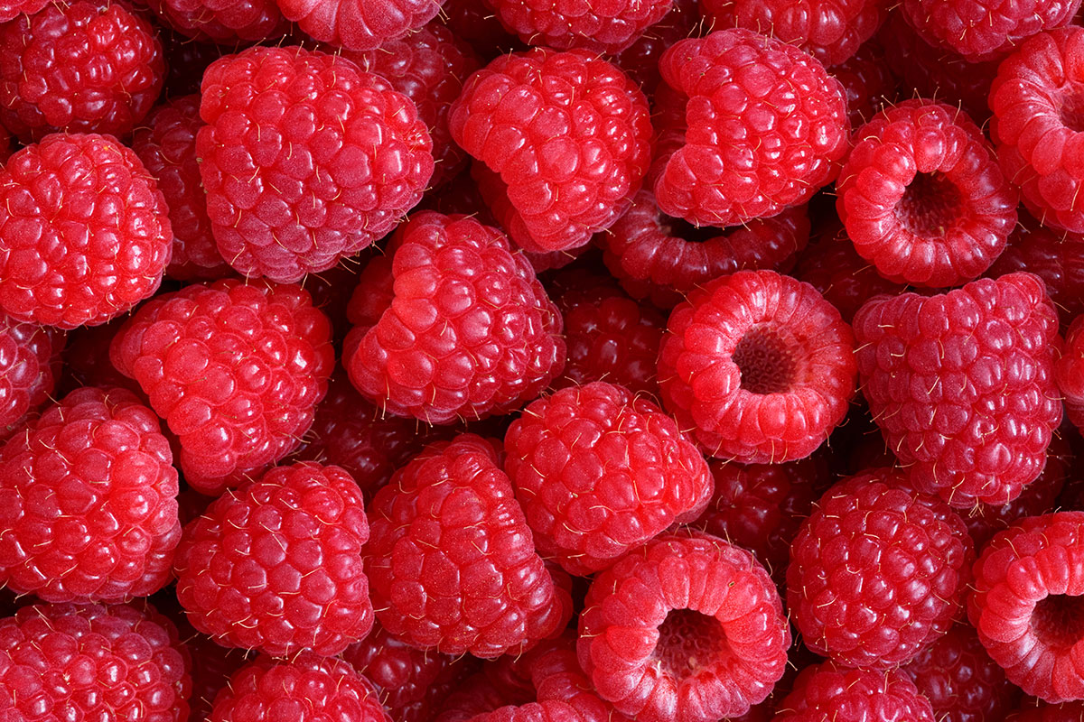

They protect your heart and have a great taste. I personally love their texture! Before going out I usually grab some of these and mix them with blueberries and just take them to work. They always help in the middle of the morning!

- Cinnamon
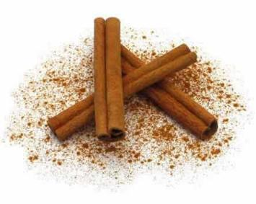

It is like a natural pain reliever. Great for people who love exercising. It helps for your muscles stiffness and urinary infections! Perfect for your afternoon tea.

- Avocado
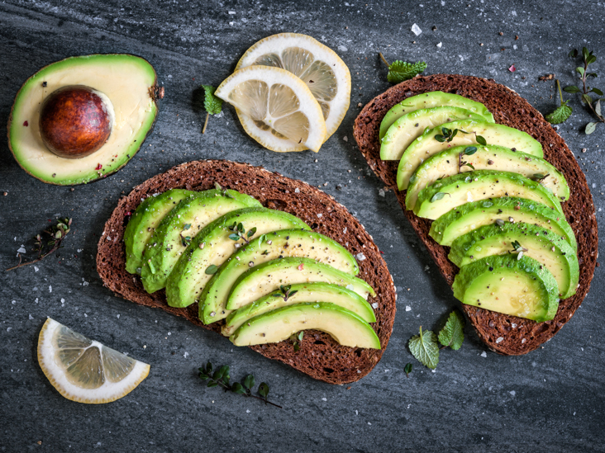

They contain lot of vitamins. It also has great olive properties that helps your body’s vascular function. It tastes awesome and goes great with almost anything! Avocado lover right here!
- Swiss chard
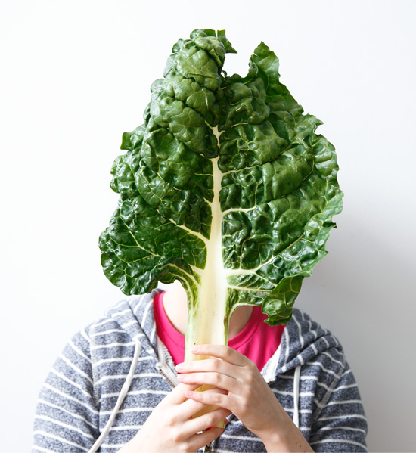

You should definitely mix it with some mushrooms and parmesan cheese. Some olive oil and pepper on top and it’s ready! The best salad in the whole world.

- Garlic
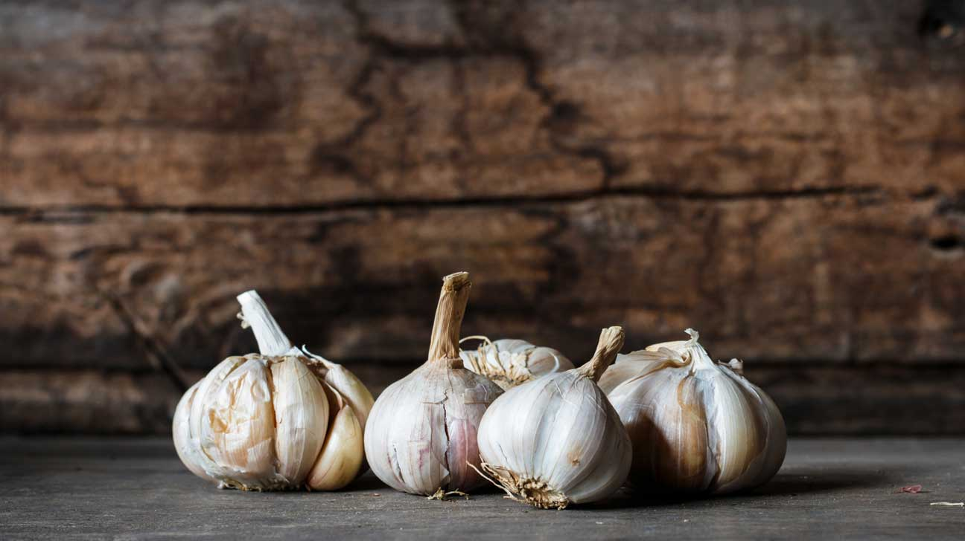

It is not only to prevent vampires! LOL. It is great for your body! It helps strengthen your bones, however, you should be careful. It smells a lot, so you should avoid it if you are going on a date!

- Sprouts
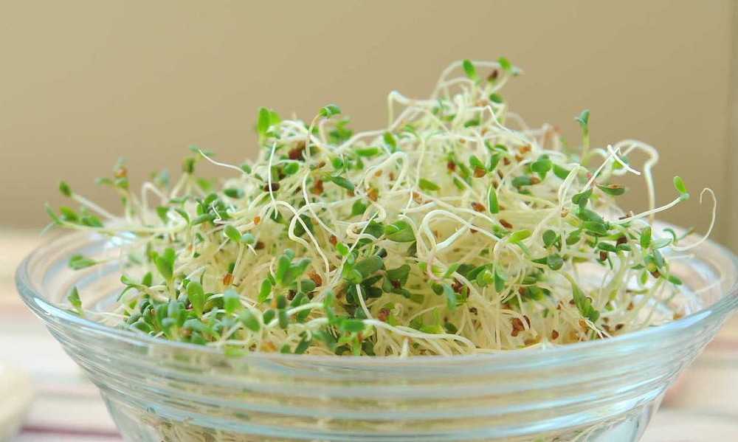

Sprouts helps you eat better as it makes you feel fuller. It is much bulkier than any other vegetable. It has the same effect inside your stomach it feels it up quicker.

- Mushrooms
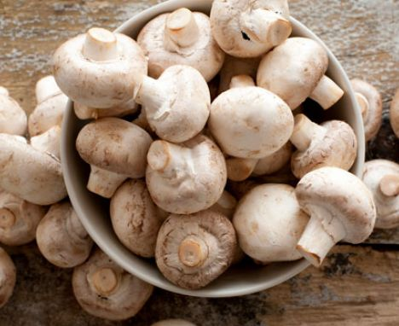

They are rich in proteins. You should season them with some garlic and parsley, then cook them on the grill. Nothing could taste better!

- Kale
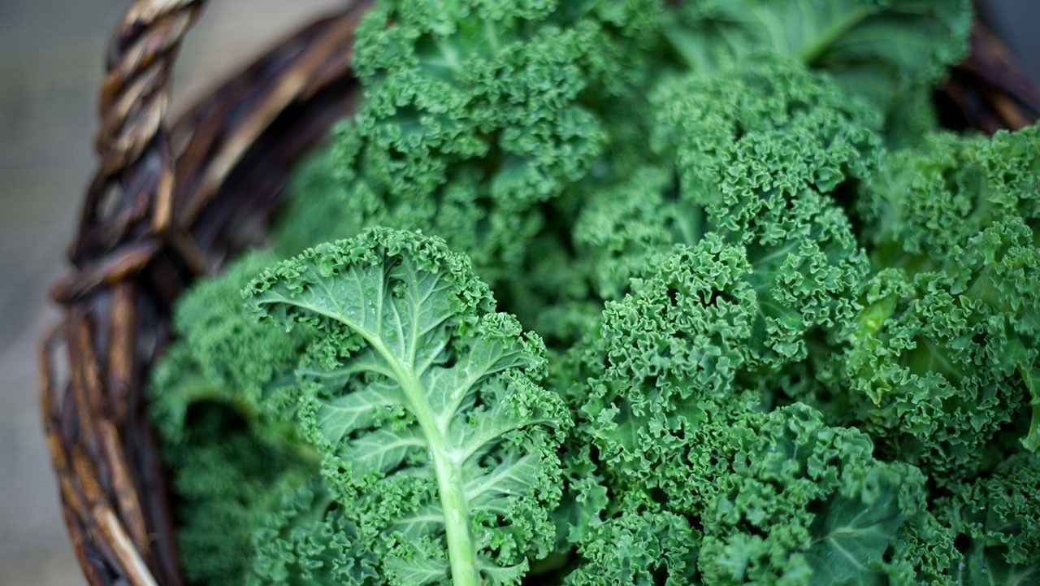

They have anti-oxidant and anti-inflammatory benefits. Now, it’s something that’s on fashion. Thankfully it is! You should try them. There is no better way of being on fashion than helping your body .

- Spinach
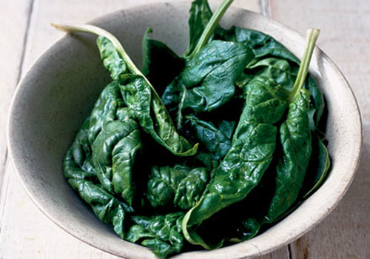

Not only to strengthen your muscles as Popeye the sailor man! They are rich in different vitamins. You can eat them boiled or in your salad!

- Collard greens
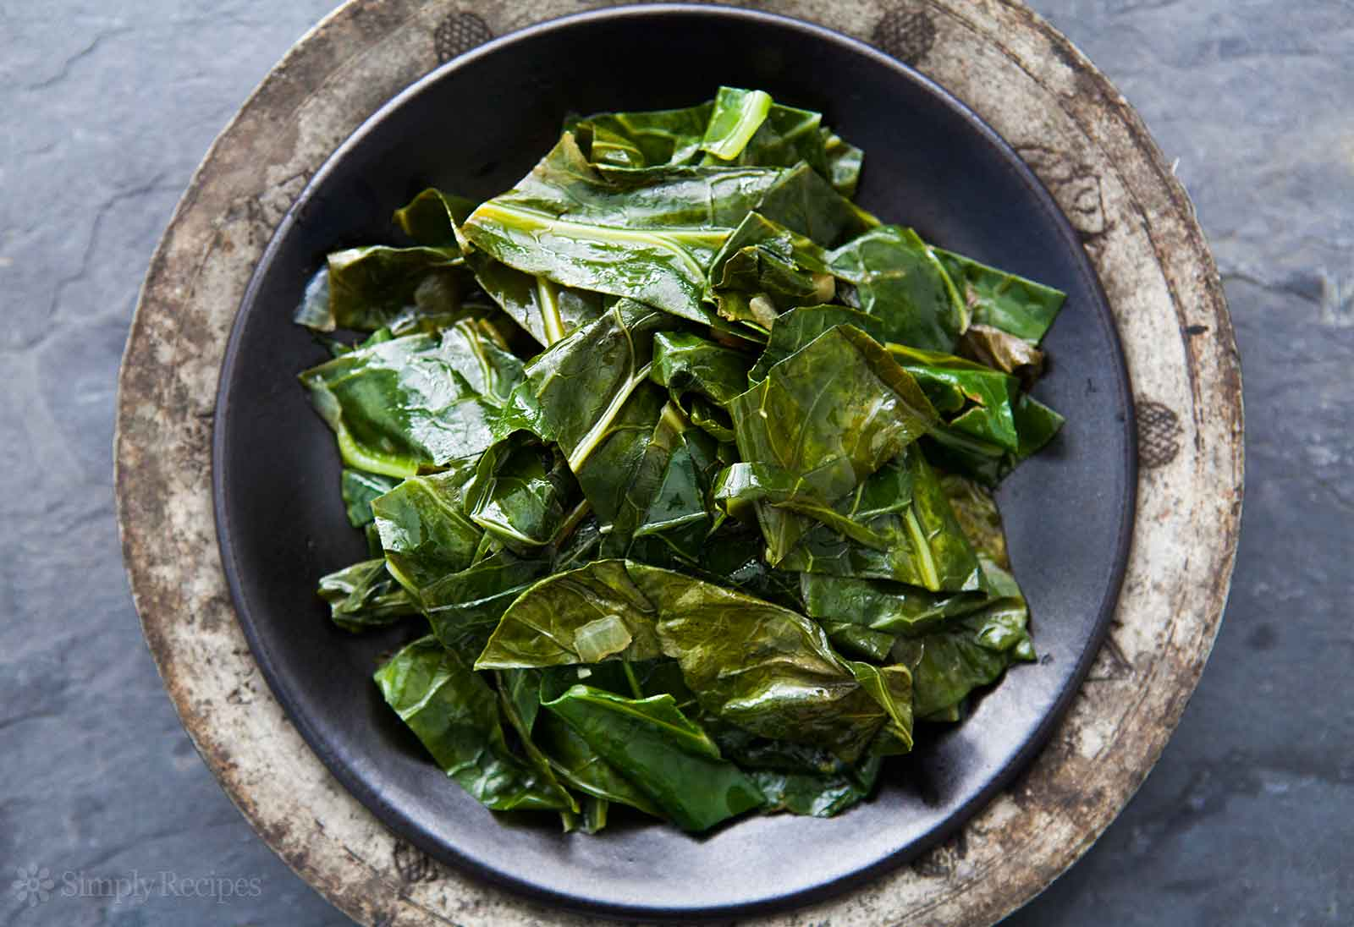

They help fighting inflammation. They are also clinically proven to combat cancer. I wish there was another way of combating it that was more official. However, if this is said to be a good natural way you should definitely try it.

- Tomatoes
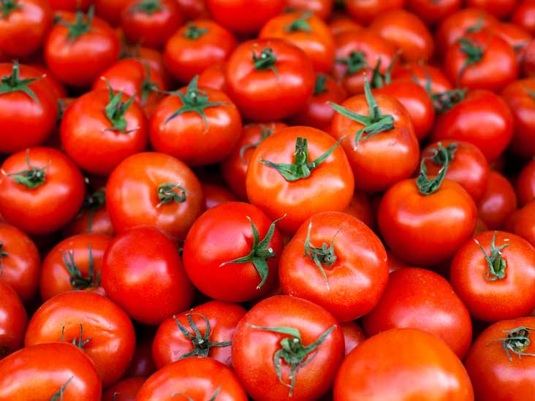

Love them! I mean just look at their color. Great red tomatoes they are so vital! It is said that they lower your risk for having a stroke significantly. People think they are vegetables but that’s not true. They are fruits actually.

